Spring Microservices Youtube









Actuator



Dashboard will useful information







Expose all in Actuator







Actuator useful endpoints







Actuator/info



metrics



Loggers



Loggers



Change logging level without restarting app



Graceful shutdown

First it service all request then it will shutdown

Disabled by default

 POST REQUEST

Docker





**Problems with Monolitic Application**

Scalability of specific module is not possible

Hard to migrate to new technology, has to be done all at once

Complexity

MicroServices

Collection of small autonomous services

Separate components in services

Scalability of independent services

Rest template (Synchronous)

Simplify communication between micro services

Service Registry ex: Spring Cloud Eureka

Enable dynamic service discovery in micro services



Job service registers to service registry

Review service request to service registry a service discovery request for job service

Service registry returns info to review service then review service can call job service

All services register itself in the Service Registry

Service Registry behind scenes

Heartbeat signal, to validate service is still up can be configured

Registry down, services will not be able to send heartbeat



Feign

Declarative web service client designed to make writing htto clients easier









From



To



FeignClient doesn’t need @LoadBalance where RestTemplate do need it for eureka service name to be found

Distributed Tracing

Enables you to trace your request from beginning to the end



Zipkin

Open source distributed tracing system



Span

Basic unit of work

Trace

Complete journey

Micrometer

Tool to check application performance



How micrometer is different than distributed tracing

Collect information of the metrics while zipkin provides info of a single request with the tracing

Configuration Management

Managing and controlling the configurations of each microservice (db, external url, caching, etc)



Spring Cloud Config Service

Support for externalized configuration in distributed system. Gives you a central place to manage external properties for applications across all environments.



Config application and url from where will fetch configuration





Config service to fetch configuration from configuration management



Can configure read from configuration management to be optional and use what is in service app properties instead



Api Gateway

Help you to route requests to its appropriate service







Lb load balance





Fault Tolerance

Ability to continue operating without operation

Ex. Failure in 1 ms does not mean complete app failure

Resilience

ability to recover quickly from difficulties

Circuit Breaker. Prevent network or service failure from cascading

Fallbacks default responses preconfigured

Timeouts

Graceful Degradation. Reduced functionality

Resilience4j

Lightweight easy to use fault tolerance library, easy to integrate with spring boot





After some failure circuit breaker changes it to closed, no more requests allowed, configured to go to half open after 10 seconds, to accept another attempt

Fallback



Service down, circuit breaker Open but no error received



Retry

Attempt configured number of times to fulfill the request, If couldn’t process it will throw the fallback





Rate Limiter

Limit of request accepted in a period of time





Asynchronous Communication

Rabbit MQ



If review service is down its ok, message will be stores in message queue for a while



Message queue

Form of asynchronous service to service communication in ms arquitectures

Producer

Service that creates a message into the message queue

Consumer

Service that consumes a message from the message queue

Channel

can be thought of as "lightweight connections that share a single TCP connection".



Producer







Consumer







Packaging

Compile source code into bytecode, bundling it with any dependent libraries and creating a single executable artifact that can be distributed and run



Hibernate entity manager vs entitymanager factory

EntityManagerFactory provides instances of EntityManager for connecting to same database.

Hibernate merge vs update

Update: if you are sure that the session does not contains an already persistent instance with the same identifier, then use update to save the data in hibernate

Merge: if you want to save your modifications at any time with out knowing about the state of an session, then use merge() in hibernate.

Hibernate merge vs refresh

MERGE - for existing objects, to merge the existing data in the table with the data in my object. (sync to database) PERSIST - is create new records from object in the database. REFRESH - is to refresh the data in the object.

Database

Get only duplicated values

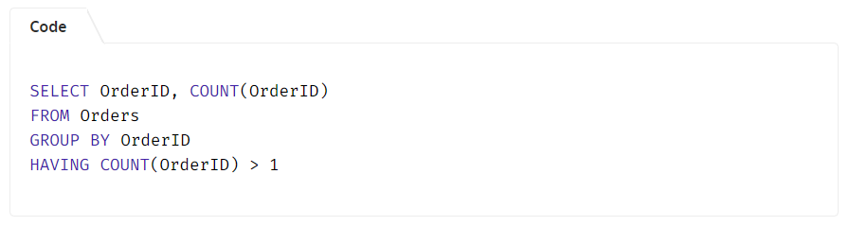

What is SQL?

SQL (Structured Query Language) is a standard programming language used to communicate with relational databases.

What are the main types of SQL commands?

SQL commands are broadly classified into:

DDL (Data Definition Language): CREATE, ALTER, DROP, TRUNCATE.

DML (Data Manipulation Language): SELECT, INSERT, UPDATE, DELETE.

DCL (Data Control Language): GRANT, REVOKE.

TCL (Transaction Control Language): COMMIT, ROLLBACK, SAVEPOINT.

SQL Transaction?

A transaction in SQL is a sequence of one or more SQL statements executed as a single unit of work. These statements could be performing operations like INSERT, UPDATE, or DELETE. The main goal of a transaction is to ensure that all operations within it should be either completed successful or rolled back entirely if an error occurs.

BEGIN TRANSACTION;

-- Deduct $150 from Account A

UPDATE Accounts

SET Balance = Balance - 150

WHERE AccountID = 'A';

-- Add $150 to Account B

UPDATE Accounts

SET Balance = Balance + 150

WHERE AccountID = 'B';

-- Commit the transaction if both operations succeed

COMMIT;

COMMIT

COMMIT command is used to save all changes made during the current transaction to the database

ROLLBACK

Rollback command is used to undo all changes made in the current transaction.

SAVEPOINT COMMAND

SAVEPOINT is used to create a checkpoint within a transaction. We can roll back to a specific SAVEPOINT instead of rolling back the entire transaction.

SAVEPOINT SP1;

//Savepoint created.

DELETE FROM Student WHERE AGE = 20;

//deleted

SAVEPOINT SP2;

//Savepoint created.

ROLLBACK TO SAVEPOINT SAVEPOINT_NAME;

RELEASE SAVEPOINT Command

This command is used to remove a SAVEPOINT that we have created. Once a SAVEPOINT has been released, we can no longer use the ROLLBACK command to undo transactions performed since the last SAVEPOINT

Monitoring and Optimizing SQL Transactions

To maintain performance and prevent issues, consider the following techniques:

1. Monitor Locks: Track locking behavior and adjust queries to minimize locking conflicts.

2. Limit Transaction Scope: Limit the number of rows or records affected by a transaction to speed up processing.

3. Use Batch Processing: If you're handling large amounts of data, break the operations into smaller transactions or batches to avoid overwhelming the system.

Default Constraint

DEFAULT constraint assigns a default value to a column when no value is provided during an INSERT operation. This helps maintain consistent data and simplifies data entry.

Normalization

Normalization is the process of organizing data in a database to reduce redundancy and improve data integrity. This involves dividing large tables into smaller, related tables and defining relationships between them to ensure consistency

Denormalization

Denormalization is the process of combining normalized tables into larger tables for performance reasons. It is used when complex queries and joins slow down data retrieval, and the performance benefits outweigh the drawbacks of redundancy.

What are the different operators available in SQL?

Arithmetic Operators: +, -, *, /, %

Comparison Operators: =, !=, <>, >, <, >=, <=

Logical Operators: AND, OR, NOT

Set Operators: UNION, INTERSECT, EXCEPT

Special Operators: BETWEEN, IN, LIKE, IS NULL

What is a view in SQL?

A view is a virtual table created by a SELECT query. It does not store data itself, but presents data from one or more tables in a structured way. Views simplify complex queries, improve readability, and enhance security by restricting access to specific rows or columns.

What is the purpose of the UNIQUE constraint?

The UNIQUE constraint ensures that all values in a column (or combination of columns) are distinct. This prevents duplicate values and helps maintain data integrity.

What are the different types of joins in SQL?

INNER JOIN: Returns rows that have matching values in both tables.

LEFT JOIN (LEFT OUTER JOIN): Returns all rows from the left table, and matching rows from the right table.

RIGHT JOIN (RIGHT OUTER JOIN): Returns all rows from the right table, and matching rows from the left table.

FULL JOIN (FULL OUTER JOIN): Returns all rows when there is a match in either table.

CROSS JOIN: Produces the Cartesian product of two tables.

What is the purpose of the GROUP BY clause?

The GROUP BY clause is used to arrange identical data into groups. It is typically used with aggregate functions (such as COUNT, SUM, AVG) to perform calculations on each group rather than on the entire dataset.

What are aggregate functions in SQL?

Aggregate functions perform calculations on a set of values and return a single value. Common aggregate functions include:

COUNT(): Returns the number of rows.

SUM(): Returns the total sum of values.

AVG(): Returns the average of values.

MIN(): Returns the smallest value.

MAX(): Returns the largest value.

What is a subquery?

A subquery is a query nested within another query. It is often used in the WHERE clause to filter data based on the results of another query, making it easier to handle complex conditions.

What is the difference between DELETE and TRUNCATE commands?

DELETE: Removes rows one at a time and records each deletion in the transaction log, allowing rollback. It can have a WHERE clause.

TRUNCATE: Removes all rows at once without logging individual row deletions. It cannot have a WHERE clause and is faster than DELETE for large data sets.

What is the purpose of the SQL ORDER BY clause?

The ORDER BY clause sorts the result set of a query in either ascending (default) or descending order, based on one or more columns. This helps present the data in a more meaningful or readable sequence.

What are indexes, and why are they used?

Indexes are database objects that improve query performance by allowing faster retrieval of rows. They function like a book’s index, making it quicker to find specific data without scanning the entire table. However, indexes require additional storage and can slightly slow down data modification operations.

What is a cursor in SQL?

A cursor is a database object used to retrieve, manipulate, and traverse through rows in a result set one row at a time. Cursors are helpful when performing operations that must be processed sequentially rather than in a set-based manner.

What is a trigger in SQL?

A trigger is a set of SQL statements that automatically execute in response to certain events on a table, such as INSERT, UPDATE, or DELETE.

What is a stored procedure?

A stored procedure is a precompiled set of SQL statements stored in the database. It can take input parameters, perform logic and queries, and return output values or result sets. Stored procedures improve performance and maintainability by centralizing business logic.

Alter command

The ALTER command is used to modify the structure of an existing database object. This command is essential for adapting our database schema as requirements evolve.

Add or drop a column in a table.

Change a column’s data type.

What is a composite primary key?

A composite primary key is a primary key made up of two or more columns.

What are the advantages of using stored procedures?

Improved Performance: Stored procedures are precompiled and cached in the database, making their execution faster than sending multiple individual queries.

Reusability and Maintenance: Once a procedure is written, it can be reused across multiple applications. If business logic changes, you only need to update the stored procedure, not every application that uses it.

What is the difference between UNION and UNION ALL?

UNION: Combines result sets from two queries and removes duplicate rows, ensuring only unique records are returned.

UNION ALL: Combines the result sets without removing duplicates, meaning all records from both queries are included.

SELECT Name FROM Customers

UNION ALL

SELECT Name FROM Employees;

WHEN

SELECT ID,

CASE

WHEN Salary > 100000 THEN 'High'

WHEN Salary BETWEEN 50000 AND 100000 THEN 'Medium'

ELSE 'Low'

END AS SalaryLevel

FROM Employees;

How does indexing improve query performance?

Indexing allows the database to locate and access the rows corresponding to a query condition much faster than scanning the entire table. Instead of reading each row sequentially, the database uses the index to jump directly to the relevant data pages.

CREATE INDEX idx_lastname ON Employees(LastName);

SELECT * FROM Employees WHERE LastName = 'Smith';

What are the trade-offs of using indexes in SQL databases?

Advantages

Faster query performance, especially for SELECT queries with WHERE clauses, JOIN conditions, or ORDER BY clauses.

Improved sorting and filtering efficiency.

Disadvantages:

Increased storage space for the index structures.

Additional overhead for write operations (INSERT, UPDATE, DELETE), as indexes must be updated whenever the underlying data changes.

Potentially slower bulk data loads or batch inserts due to the need to maintain index integrity.

In short, indexes make read operations faster but can slow down write operations and increase storage requirements.

What are temporary tables, and how are they used?

Temporary tables are tables that exist only for the duration of a session or a transaction. They are useful for storing intermediate results, simplifying complex queries, or performing operations on subsets of data without modifying the main tables.

CREATE TABLE #TempResults (ID INT, Value VARCHAR(50));

INSERT INTO #TempResults VALUES (1, 'Test');

SELECT * FROM #TempResults;

What is a sequence in SQL?

A sequence is a database object that generates a series of unique numeric values. It’s often used to produce unique identifiers for primary keys or other columns requiring sequential values.

What is the difference between a local and a global temporary table?

Local Temporary Table:

Prefixed with # (e.g., #TempTable).

Exists only within the session that created it.

Automatically dropped when the session ends.

Global Temporary Table:

Prefixed with ## (e.g., ##GlobalTempTable).

Visible to all sessions.

Dropped only when all sessions referencing it are closed.

CREATE TABLE #LocalTemp (ID INT);

CREATE TABLE ##GlobalTemp (ID INT);

What is the purpose of the SQL MERGE statement?

The MERGE statement combines multiple operations INSERT, UPDATE, and DELETE into one. It is used to synchronize two tables by:

Inserting rows that don’t exist in the target table.

Updating rows that already exist.

Deleting rows from the target table based on conditions

Microservices

What are Microservices?

Microservices is an architecture in which the application performs as a loosely coupled service that can be developed, deployed, and maintained independently.

Microservices are useful when the application or our project needs to be more scalable and manageable or requires more resources.

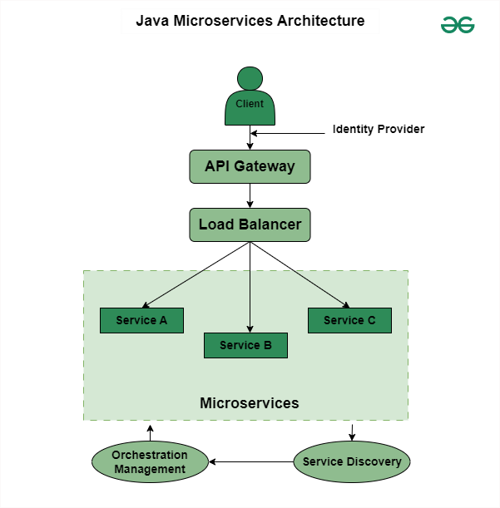

Design patterns of Java Spring Boot Microservices.

Service Registry and Discovery: Services automatically register in a central registry, allowing others to identify and interact with them dynamically.

API Gateway: It acts as a customer entry point and forwards requests to appropriate microservices to provide additional functionality such as authentication and rate limits.

Circuit Breaker: It monitors the availability of services and protects from failures by sending requests or by providing responses if service is unavailable.

CQRS (Command Query Responsibility Segregation): It separates the read and write operations. Also, it optimizes each and every operation separately for efficiency.

Saga Pattern: It manages distributed tasks by organizing a sequence of local transactions.

Database per service: Each of the services has separate databases. This ensures data isolation and also enables scaling and individual development.

Asynchronous messaging: Each services communicate with each other through message queues like Kafka or RabbitMQ.

What are the Main Components of Java Spring Boot Microservices?

The main components of Java Spring Boot Microservices include:

Services

Service Registry

API Gateway

Cloud Infrastructure

Containerization and Orchestration

Message Broker

Security

Monitoring

How do Microservices Communicate with each other?

In Microservices, multiple services run independently. Services communicate with each other through,

HTTP/REST: These are light-weight protocols used for perform communication between two services.

Message queues: Message queues such as Kafka or RabbitMQ used to make connection.

What is WebClient and How Java Microservices Communicate using WebClient?

An interface called WebClient represents the primary access point for web requests. It is also known as Reactive Web Client that is introduced in Spring 5. The new client is a non-blocking, reactive solution that works over HTTP/1.1 protocol. Also, it is the replacement of classic RestTemplate. We can use the WebClient for Java Microservices Communication by the following approach.

What is RestTemplate and How Java Microservices Communicate using RestTemplate?

The RestTemplate is a synchronous REST client that performs HTTP requests by using a simple API of template style.

What is FeignClient and How Java Microservices Communicate using FeignClient?

FeignClient is known as Spring Cloud OpenFeign.

It is a declarative REST Client in Spring Boot Web Application. Declarative REST Client means to specify the client specification as an Interface and spring boot will take care of the implementation.

With the help of FeignClient, writing web services is very simple.

It is mostly used to consume REST API endpoints exposed by third parties or microservices.

FeignClient(name = "giveHereServiceName", url = "provideUrlHere", path = "provideContextPathHere")

public interface AddressClient {

@GetMapping("/address/{id}")

public ResponseEntity<AddressResponse> getAddressByEmployeeId(@PathVariable("id") int id);

Load balancing ex nginx

Load balancing is the process of distributing traffic among different instances of the same application.

Load Balancing are two types:

Client-Side Load Balancing

the decision about which instance of the service to route the request to is made by the client itself

Server-Side Load Balancing

Server-side load balancing is performed by the infrastructure layer between client requests and service instances. This layer receives requests from clients and routes them to available service instances based on factors such as load, availability, and other metrics.

Horizontal Scaling:

Adding more servers or instances to handle the load. Ideal for larger applications with significant growth potential, distributing workload across multiple servers.

Circuit Breaker pattern in Microservices

The Circuit Breaker pattern is a fault-tolerance mechanism used in microservices to prevent cascading failures. It monitors for failures in remote service calls and, if a failure threshold is reached, opens the circuit, diverting subsequent calls to a fallback mechanism.

API gateways in a Spring Boot microservices architecture.

API gateways in Spring Boot act as an entry point for clients to access microservices. They provide features like authentication, authorization, rate limiting, and request routing while also simplifying the client-side interface by aggregating multiple microservices into a single endpoint.

How do you ensure security in a Spring Boot microservices architecture?

Security in Spring Boot microservices can be ensured by implementing features like authentication and authorization using Spring Security. This includes techniques such as OAuth2 for token-based authentication and role-based access control.

What is Eureka, and what is its role in microservices architecture?

Eureka is a service registry and discovery server provided by Netflix. Its role in microservices architecture is to help services register themselves and discover other services dynamically, enabling communication between them.

Api Gateway

Oauth2

Redis

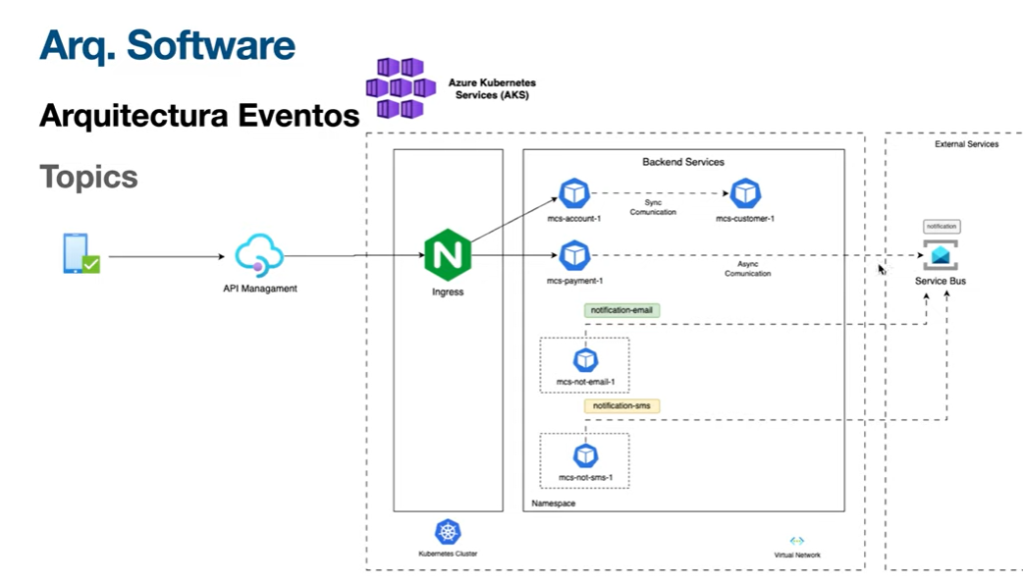

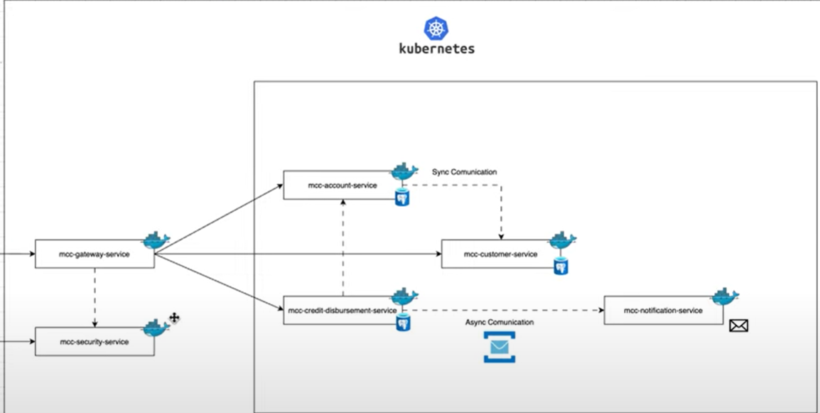

@Entity

JPA Entity

@RequestBody

public CustomerDTO addCustomer(@RequestBody CustomerDTO customerDTO){

return this.customerService.add(customerDTO);

}

@PathVariable

@GetMapping("cu/{cu}")

public CustomerDTO getCustomerByCu(@PathVariable String cu){

return this.customerService.getByCU(cu);

}

JPA Repository

@Repository

public interface IAccountRepository extends JpaRepository<AccountEntity, String> {

Optional<AccountEntity> findByAccountNumberAndCustomerCu(String username);

}

OpenFeign

a declarative REST client for Spring Boot apps.

Feign makes writing web service clients easier with pluggable annotation support, which includes Feign annotations and JAX-RS annotations.

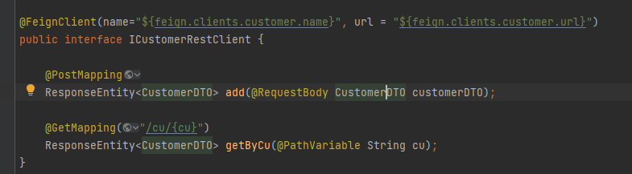

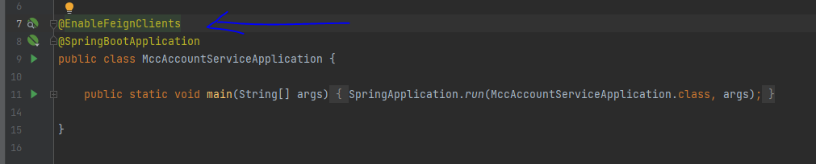

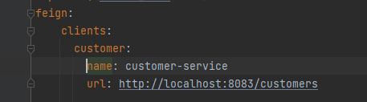

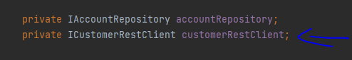

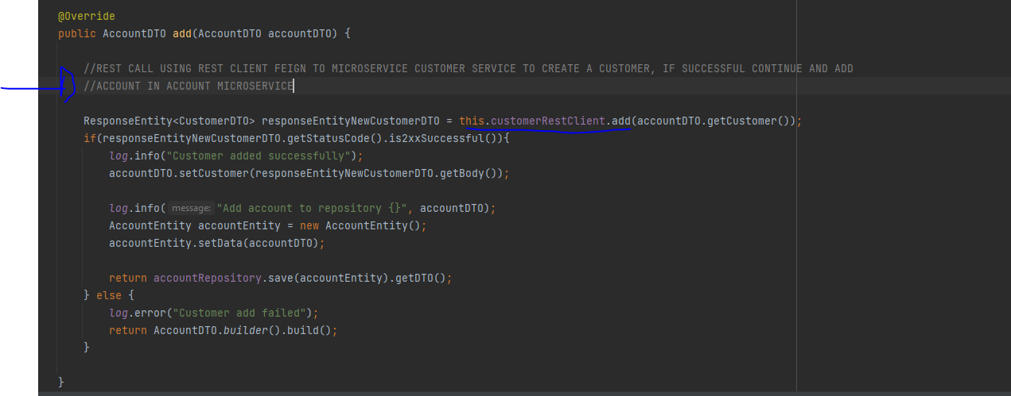

@RequestBody

To get an object into a parameter (send from postman the object in the body and catch it in here)

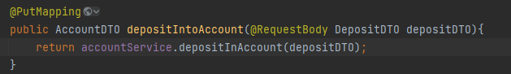

Azure Service Bus

Azure Service Bus is a fully managed cloud messaging service that facilitates communication between applications and services, especially in distributed or hybrid environments. It allows for reliable and asynchronous data transfer, decoupling systems and enabling scalable messaging patterns like queues and topics, according to Microsoft.

In yaml

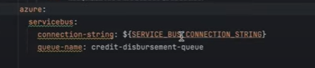

Service bus connection obtained from azure after created it and added the queue in azure as well, queue -> credit-disbursement-queue

Add dependency of azure

Create service bus builder

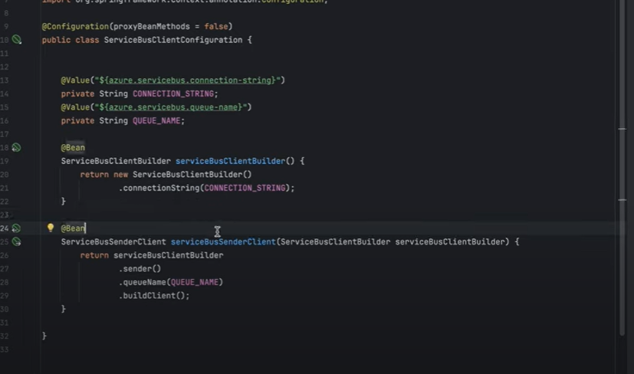

Se utiliza el service bus client para mandar a la queue un mensaje

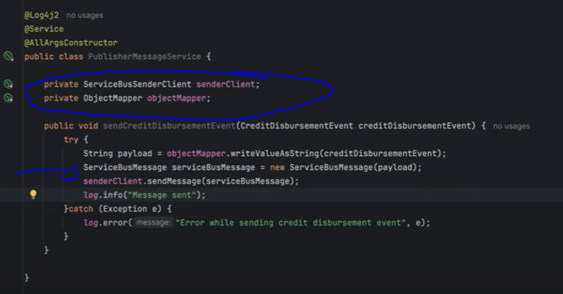

Créate the message evento, use the sender service to send the event to the desired queue

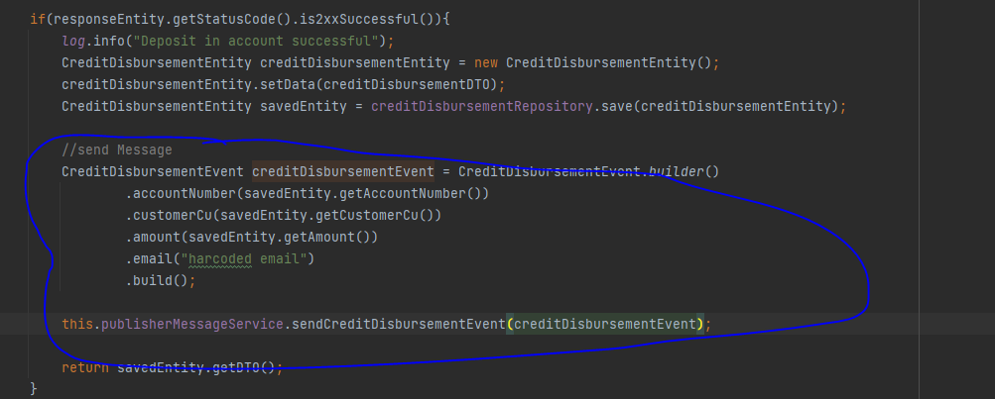

@Value

Get a property and use it as value

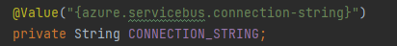

Listener Bus events subscriptor

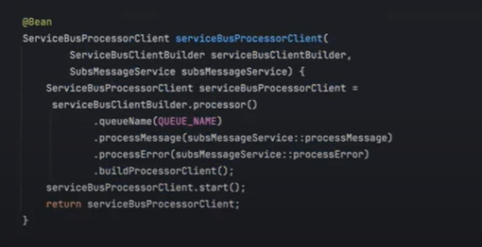

Get message from the queue

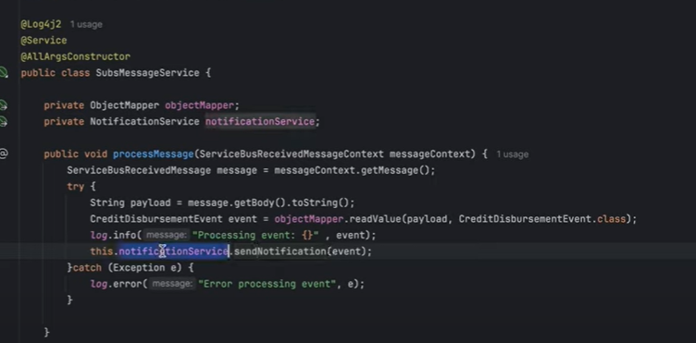

To send message

Create client which has the queue information, create event, send the message

Goes into the queue

To receive the message

Create a client with queue information, what to do to process, what to do in error case, start listener, when an event gets into the queue it its processed by the listener client

Java Mail sender, spring boot api to send mails, ex

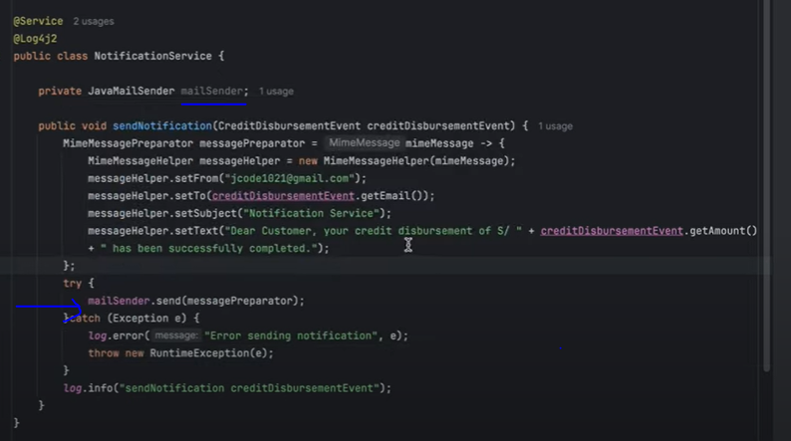

Api Gateway

We have 4 different micro services in 4 different ports, it is not suitable to be calling each port on each request, gateway instead will receive all the request and redirect to the right micro service.

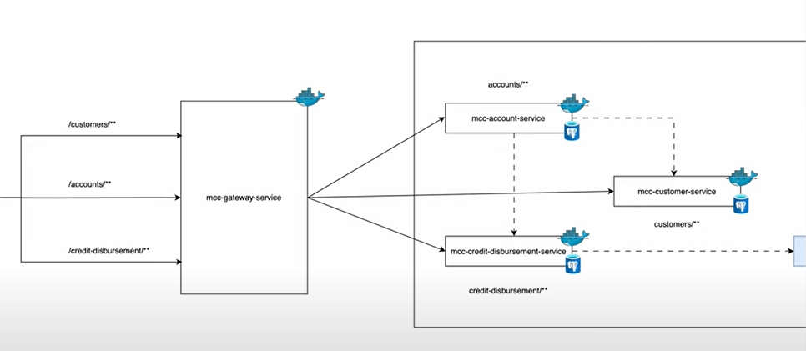

Configure routes gateway will handle

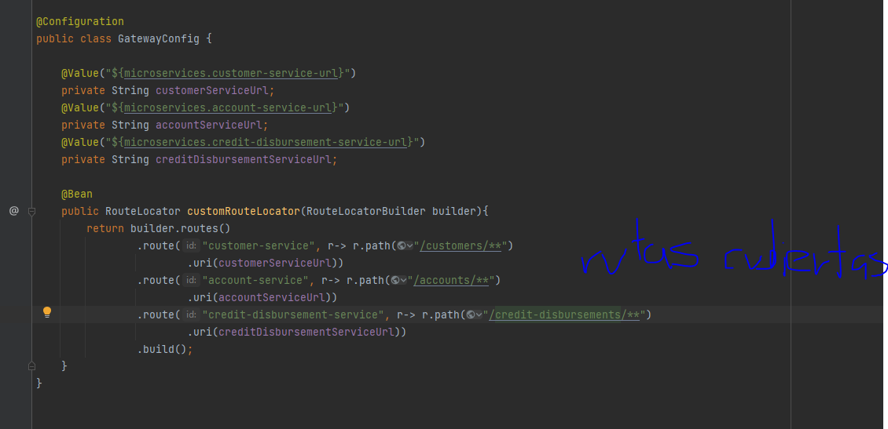

Configure gateway microservice port

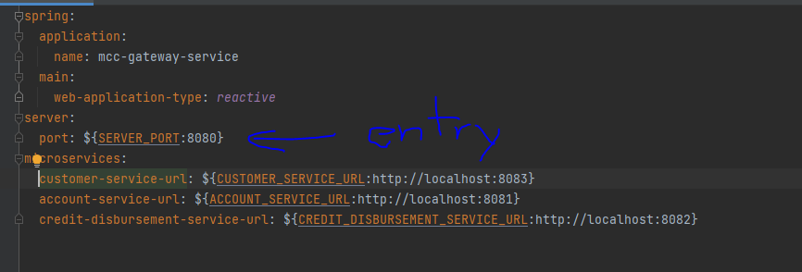

OAuth

By adding the dependency only, if you send a request to the micro service, it will ask for a token or return 401 unauthorized If not sent

OAuth allow users to grant access to his data to a third party application without sharing login credentials. It's a way to delegate access, providing a secure method for applications to interact on behalf of a user. Essentially, OAuth lets users control which applications can access their information and what specific data they can access.

Access token

OAuth uses access tokens, which are temporary credentials, to grant permission to third-party applications.

How it works:

The user initiates the authorization process by clicking a link or button to grant access to a third-party application.

The application is redirected to a website (often the service provider's) for user authentication.

If the user successfully authenticates, the service provider issues an access token and redirects the user back to the application.

The application can then use the access token to interact with the service provider and access the user's data on their behalf.

Configure port and applications

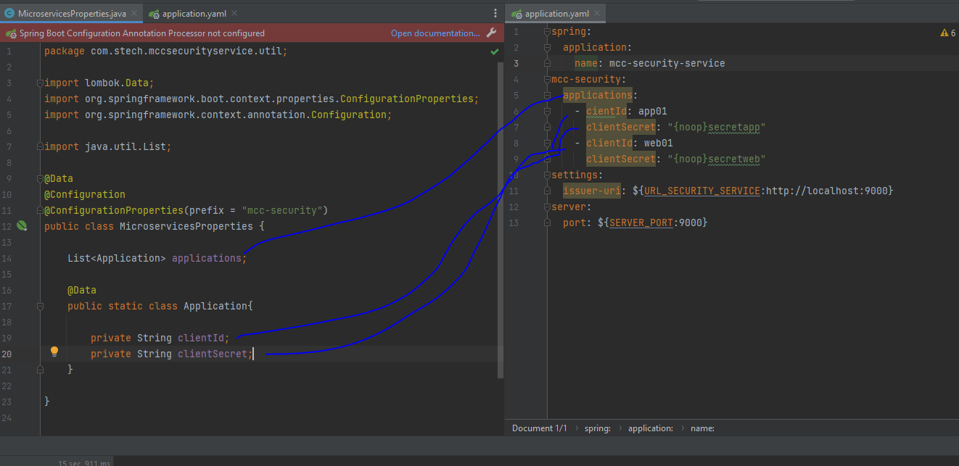

Configure OAuth2 settings

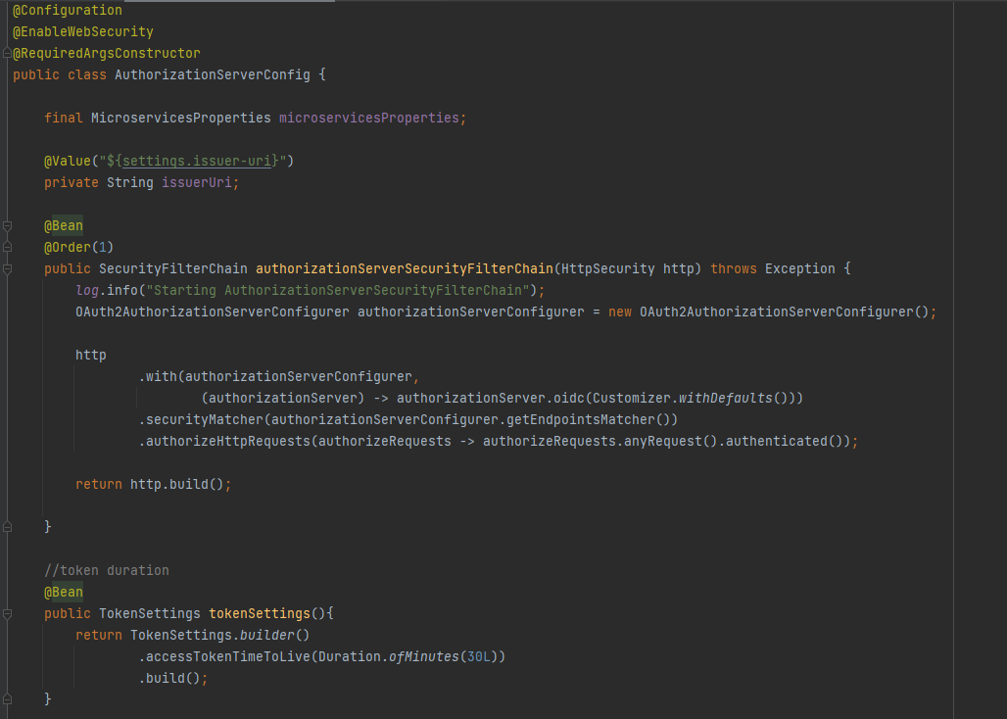

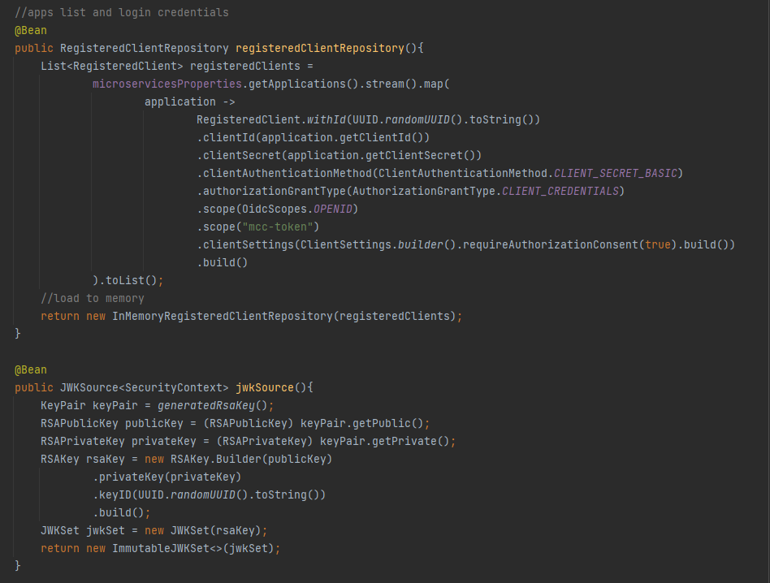

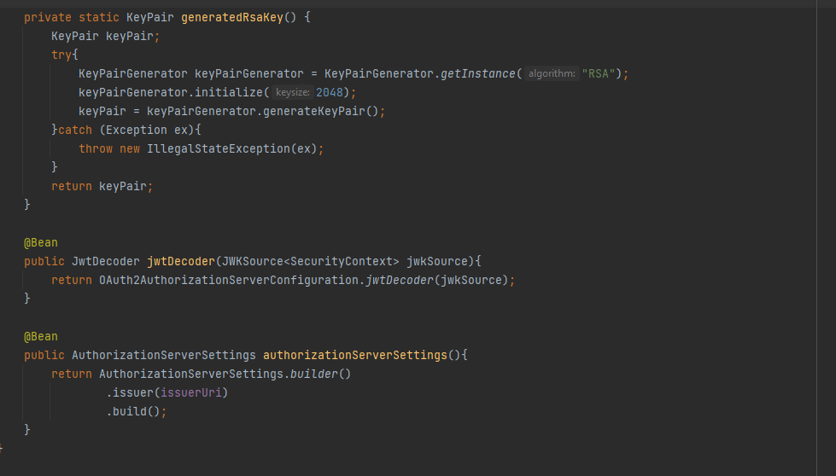

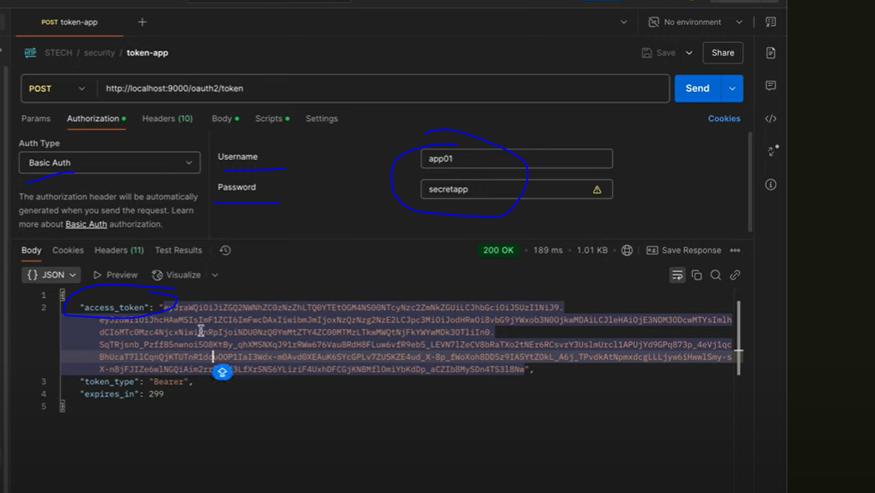

At gateway configure to look for oauth2

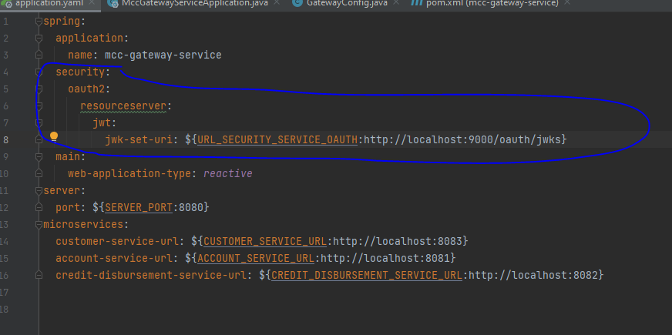

Circuit Breaker

The circuit breaker pattern is a design approach used in software development to enhance system resilience and prevent cascading failures in distributed systems.

States:

A circuit breaker typically has three states:

Closed: The initial state where calls are allowed to pass through.

Open: When the failure threshold is reached, the circuit breaker blocks calls to the service.

Half-Open: After a timeout period, a limited number of calls are allowed to pass through to check if the service has recovered. If successful, the circuit breaker returns to the closed state. If they fail, the circuit breaker returns to the open state

Thresholds:

The circuit breaker's behavior is controlled by thresholds, such as the number of failures before opening the circuit and the timeout period before attempting a half-open state.

Fallback:

When the circuit breaker is open, a fallback mechanism is typically used to provide an alternative response, such as a cached result or a default value.

Config threshold 50 request reach then open circuit

Wait 10 seconds then half open circuit

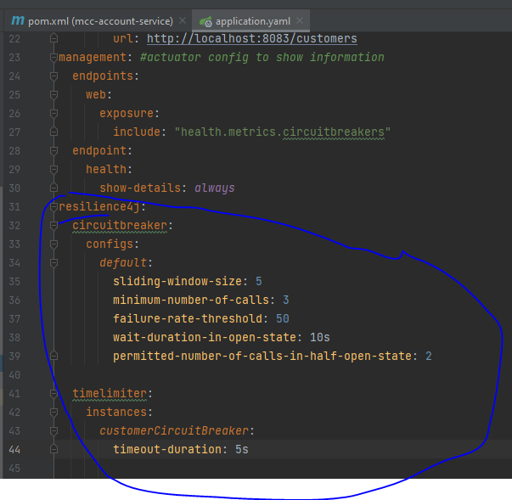

Ex Circuit Breaker

Fill configurations in yaml or properties file

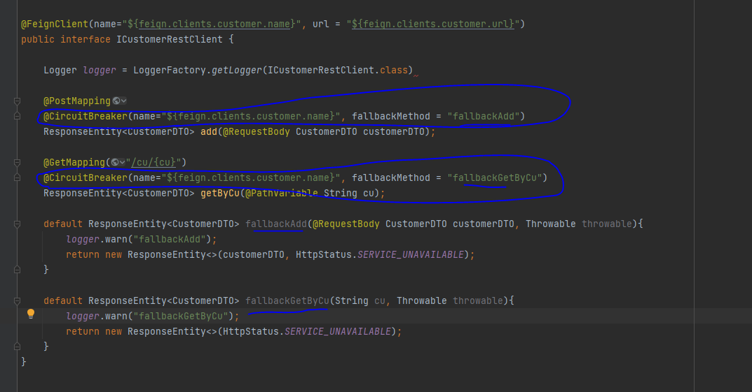

From gateway config circuit breaker

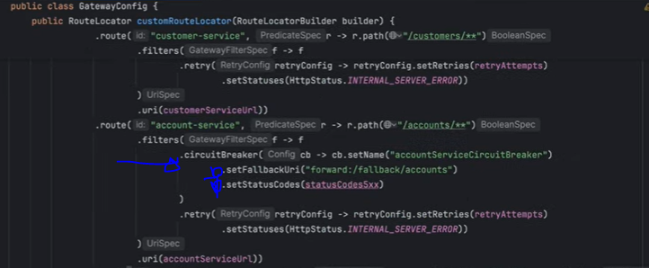

KAFKA

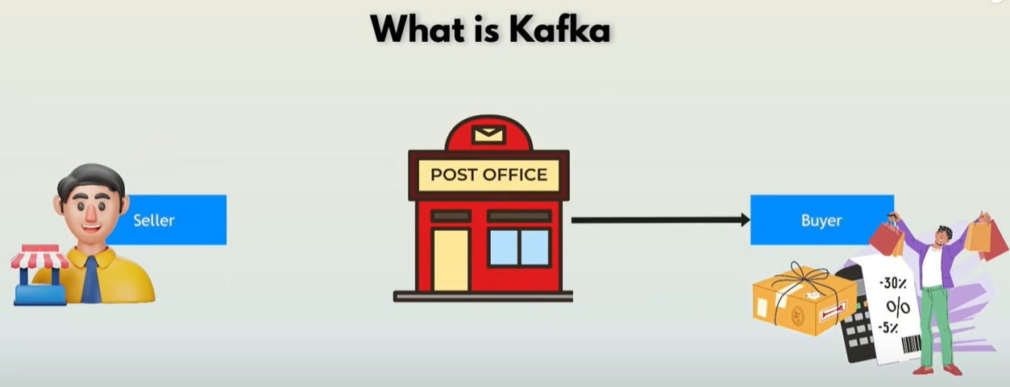

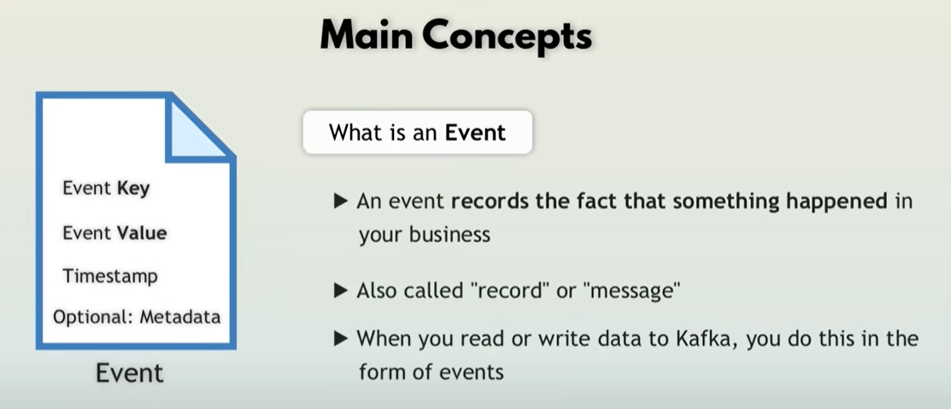

Producers

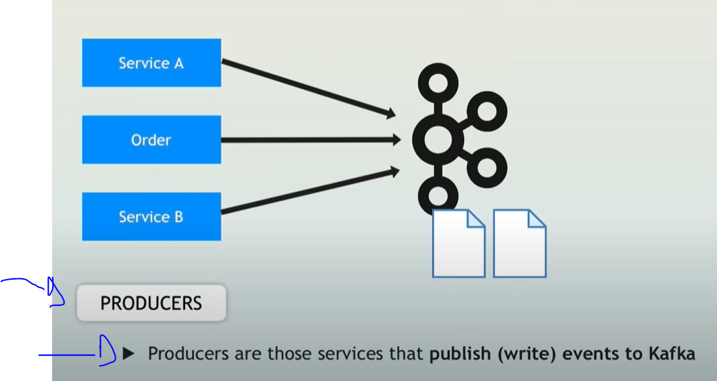

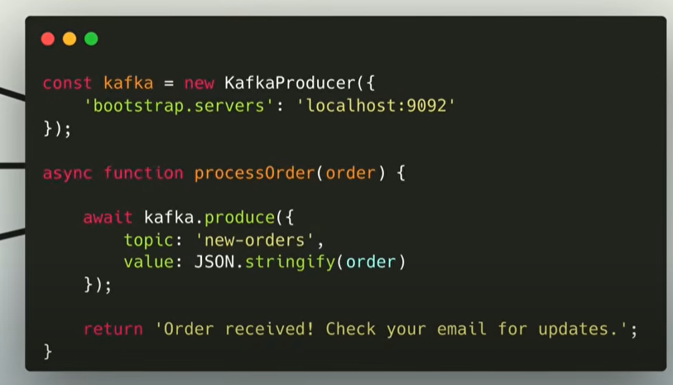

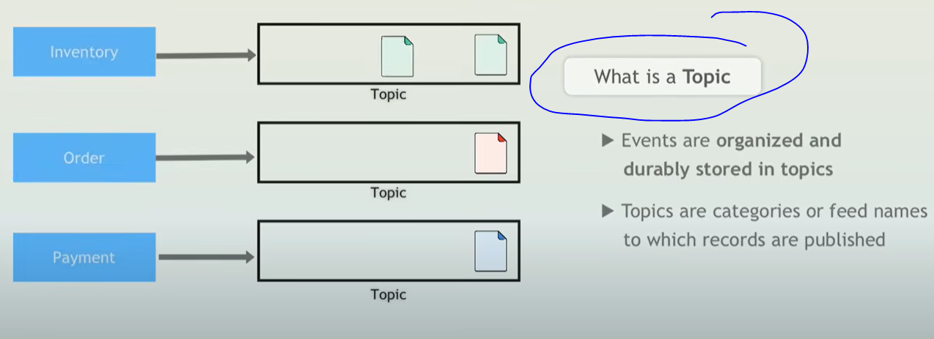

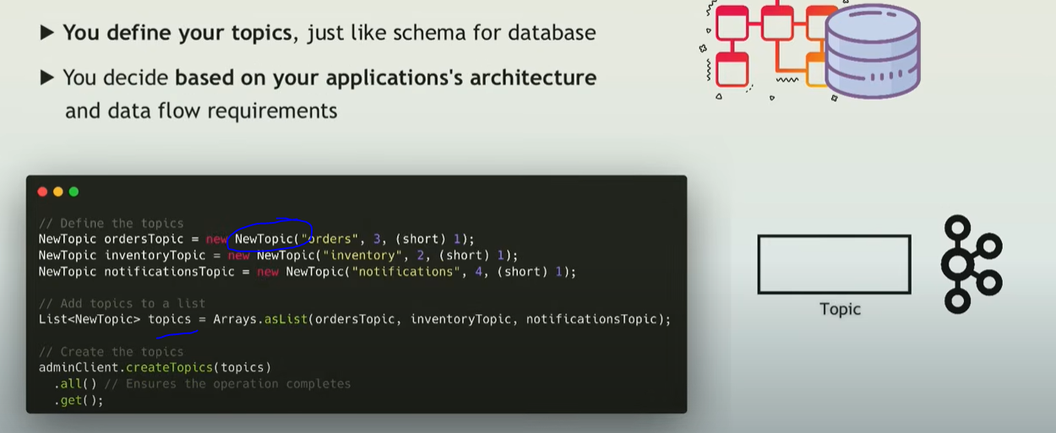

ORDER EVENT

Order event sends to the order topic and other actions are triggered

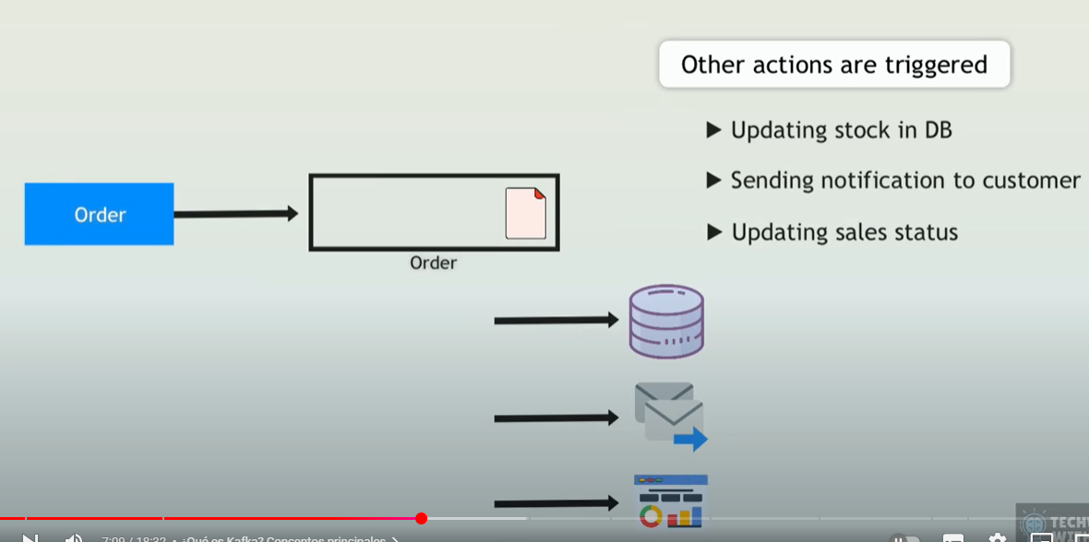

Consumers

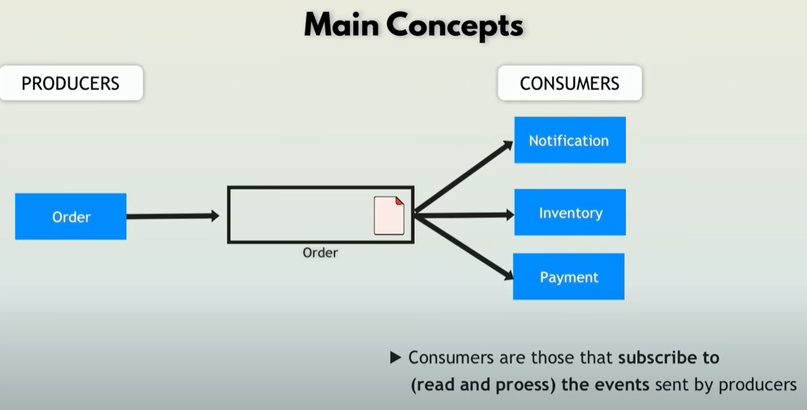

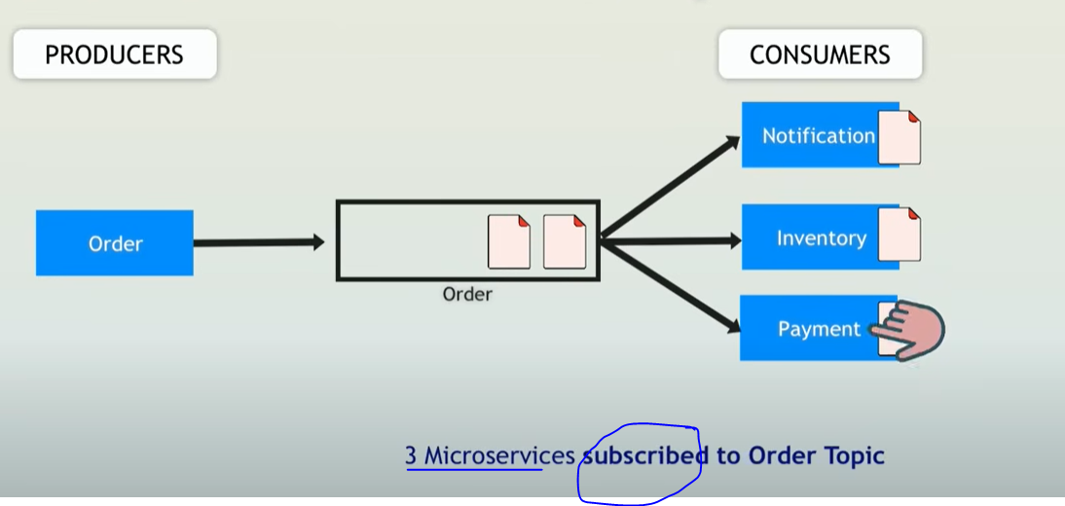

Order event is triggered, it is send to the order topic, notification, inventory and payment services are consumers of the order topic, when there is a event added to the topic, the generate an action, one of those actions could send the event to another topic, for example inventory consumes from the order topic and then triggers an event adding the event to the inventory topic.

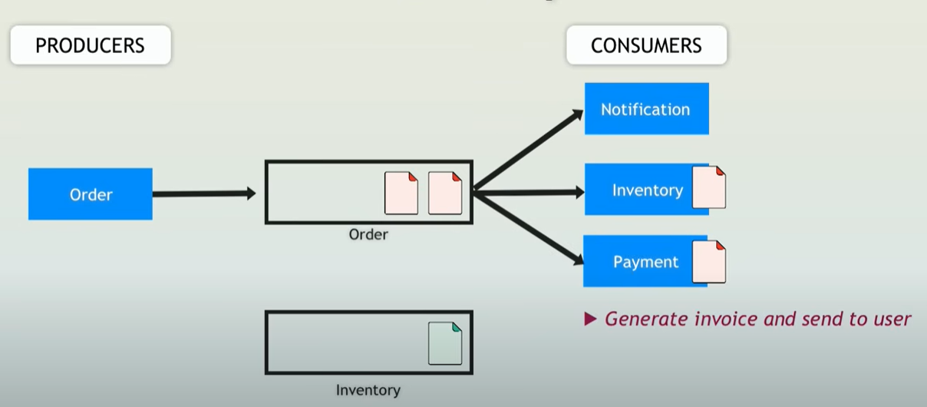

Chain of events, inventory send to the topic inventory, alerts is consuming this topic, and if below threshold, then send an event to the re-stock topic, which when consumes an event will trigger an action to fill again inventory

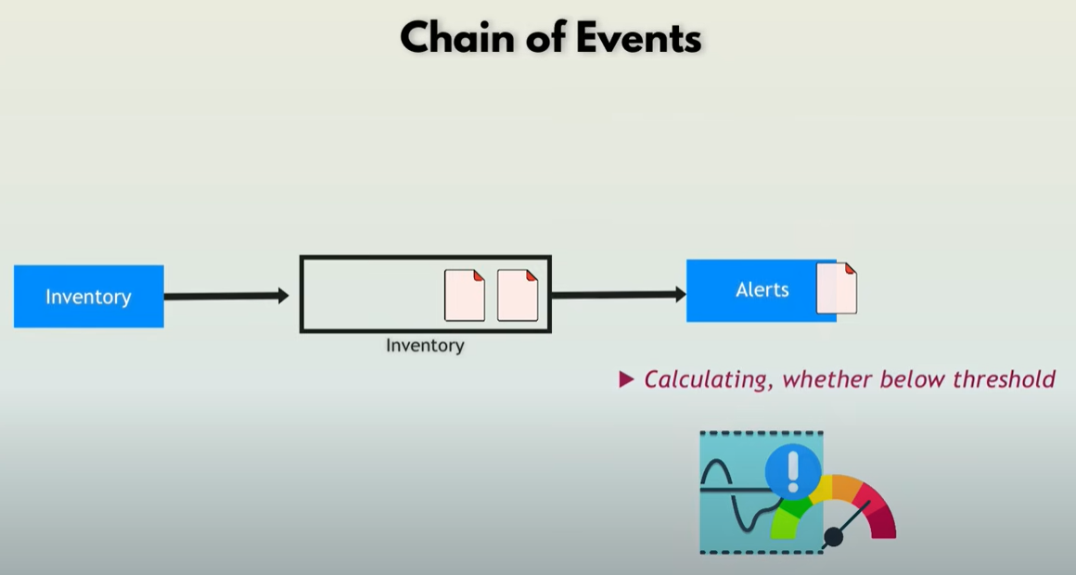

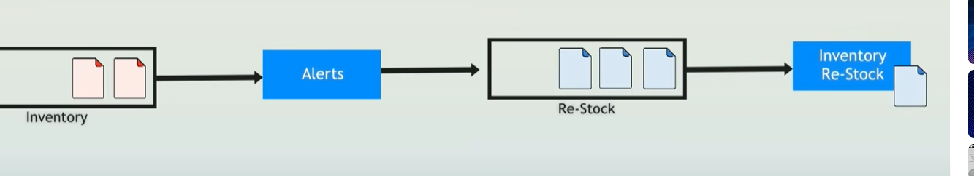

Real time processing (Streams)

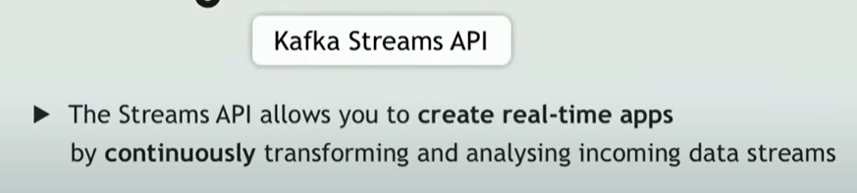

Difference Individual Process and Streams

Producer Consumer processes messages individually

Streams is a continuous real time flow of records, you don’t need to explicitly request new records, you just receive them

Streams:

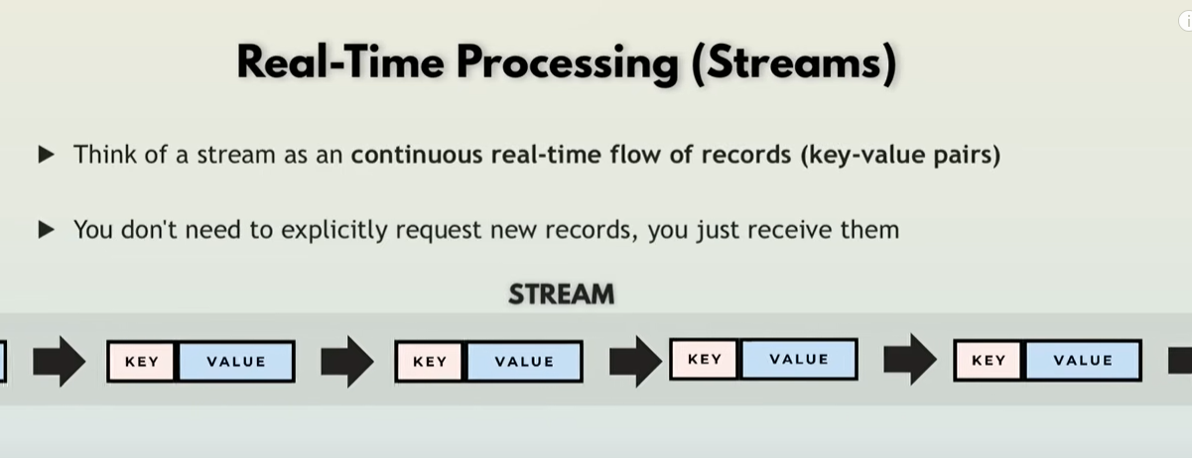

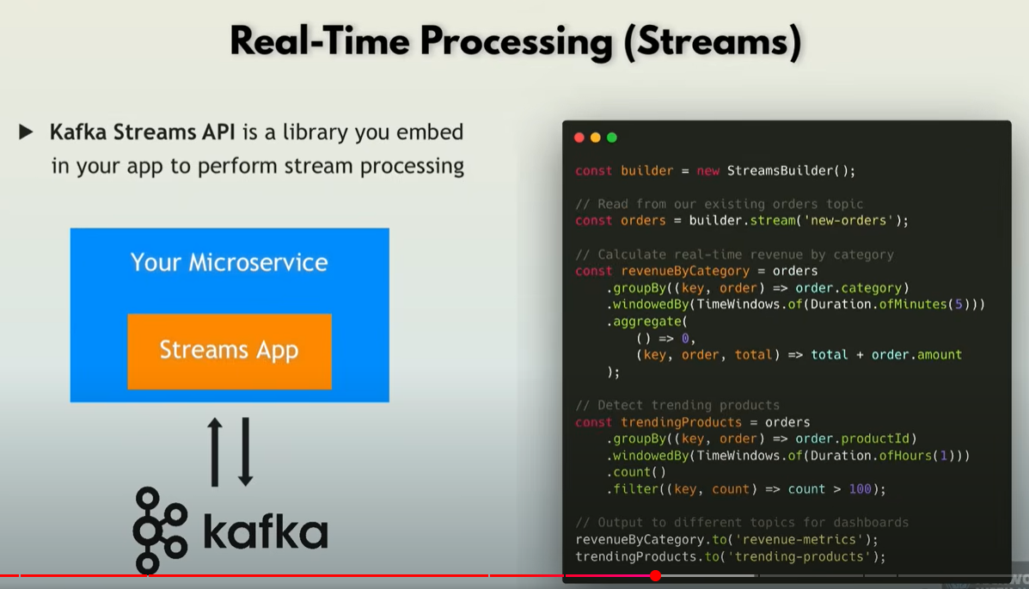

Scability with partitions

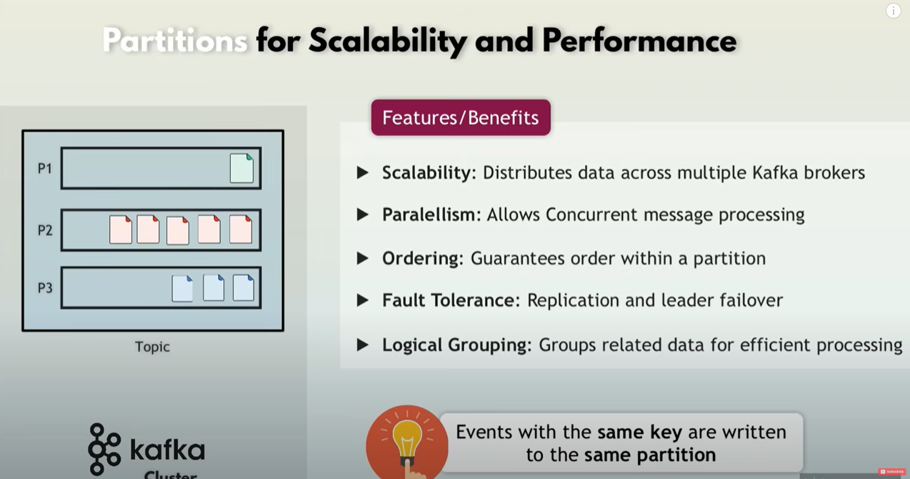

Offset

offset is a sequential integer identifier assigned to each message within a partition of a topic.

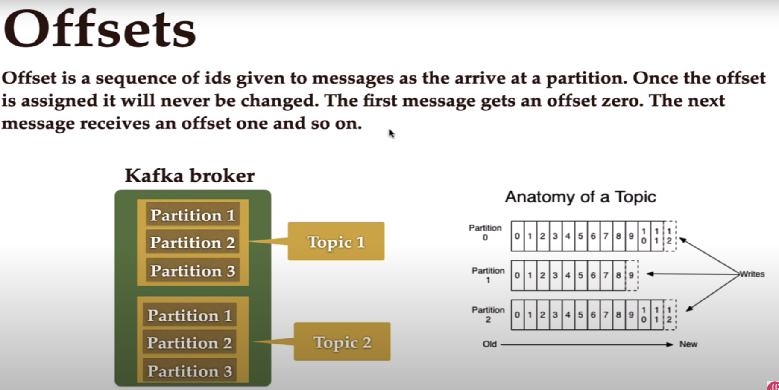

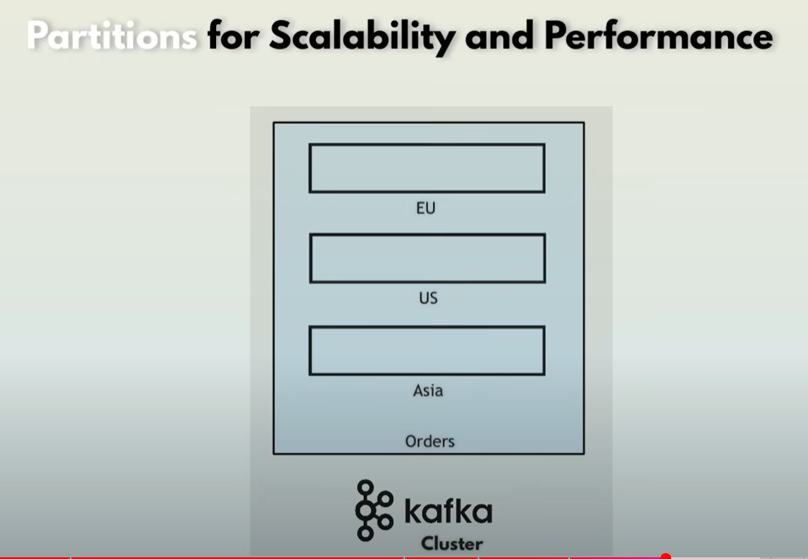

Consumer groups for scalable message consumption

If we use partitions in order to process huge amount of events ( adding partitions for example divided into regions, us, Europe, asia), then its going to be a huge amount also for the consumer who is listening to the partitions, for this we have consumer groups, using the groupId to identify which groups go together

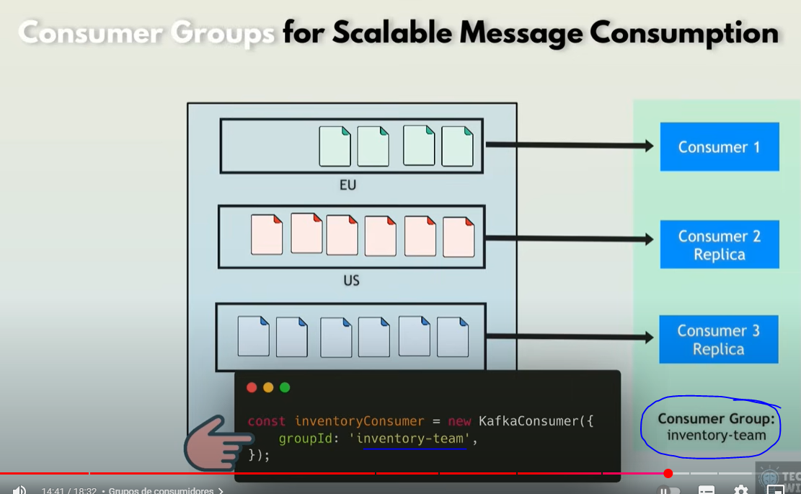

Whenever a replica consumer is up or down, kafka distributes load automatically for the new available consumers

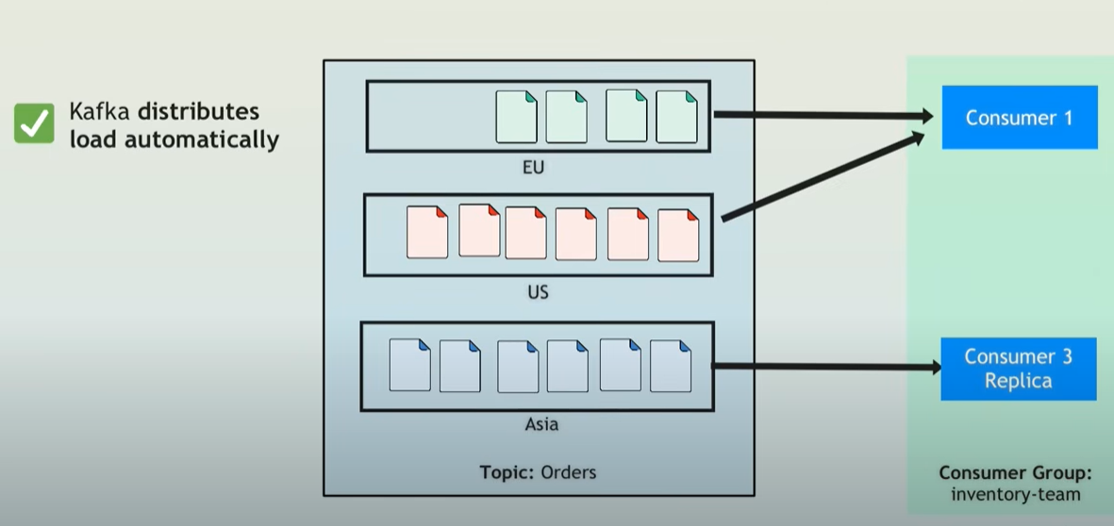

Kafka Broker

Server that stores data (messages) in topics, manages message distribution to consumers

Topics partitions are distributed across multiple brokers, for fault tolerance

Each partition has a leader brojer and multiple replicas, in case a kafka broker goes down, there will be another with a replica of the partition, for fault tolerance

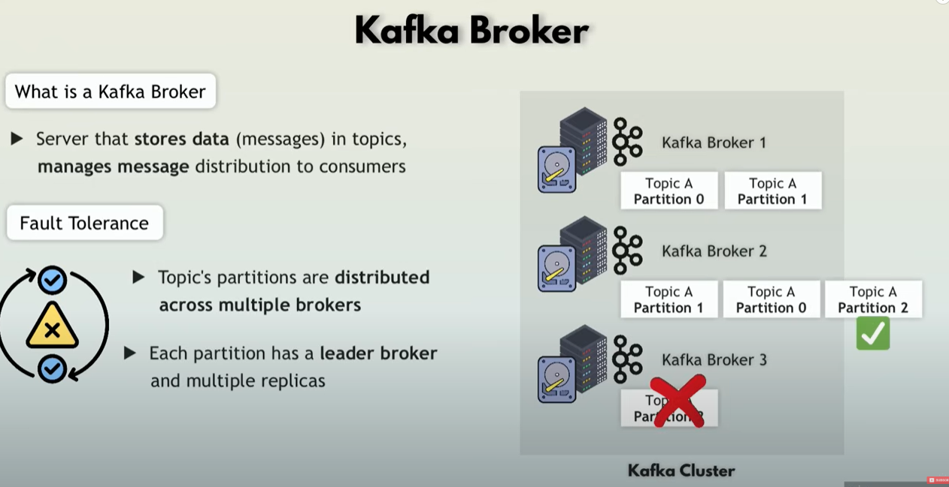

**Kafka vs rabbit or active mq**

In rabbit or active mq, messages are deleted after consumption where in kafka you can configure a retention period where it will be stored for that time on a disk.

Keeping data allows you to use for analytics

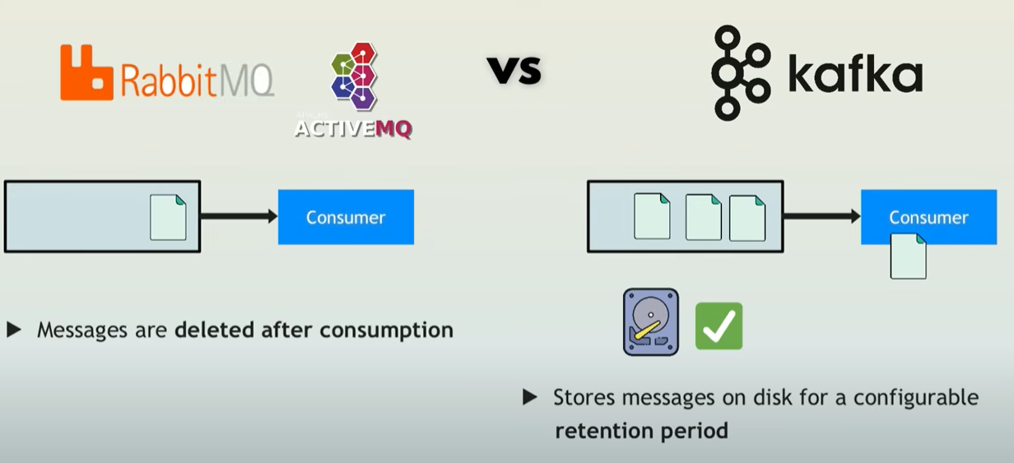

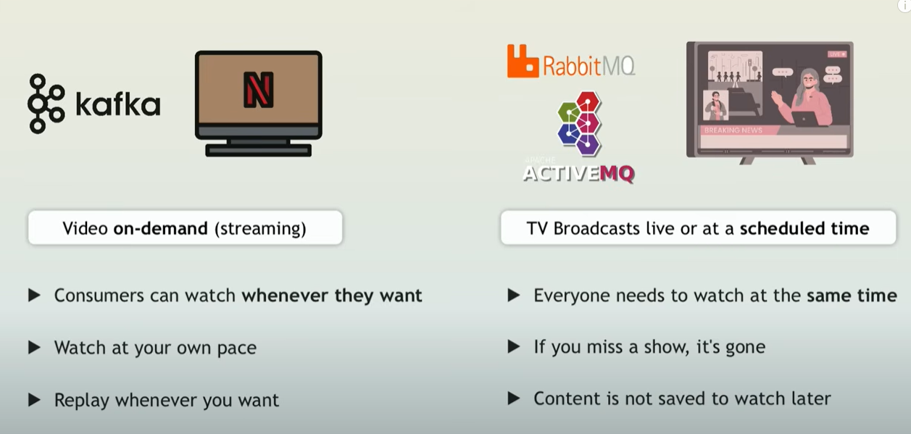

Zookeeper

External dependency used by kafka before version 3, to manage and coordinate tasks for distributed systems

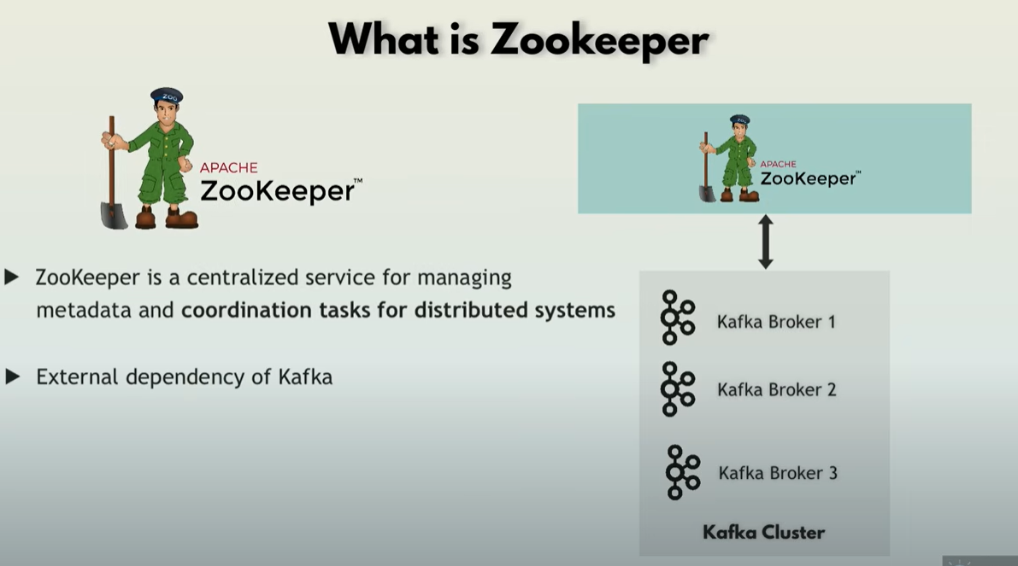

Kafka 3.0 introduced kraft which removes zookeeper

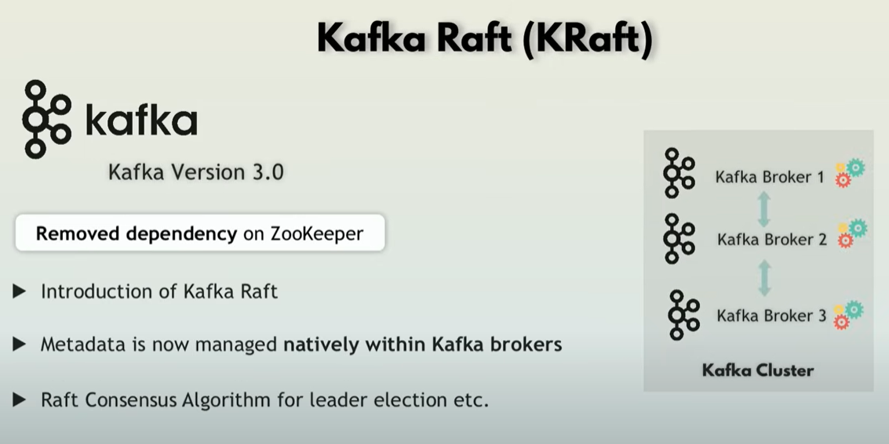

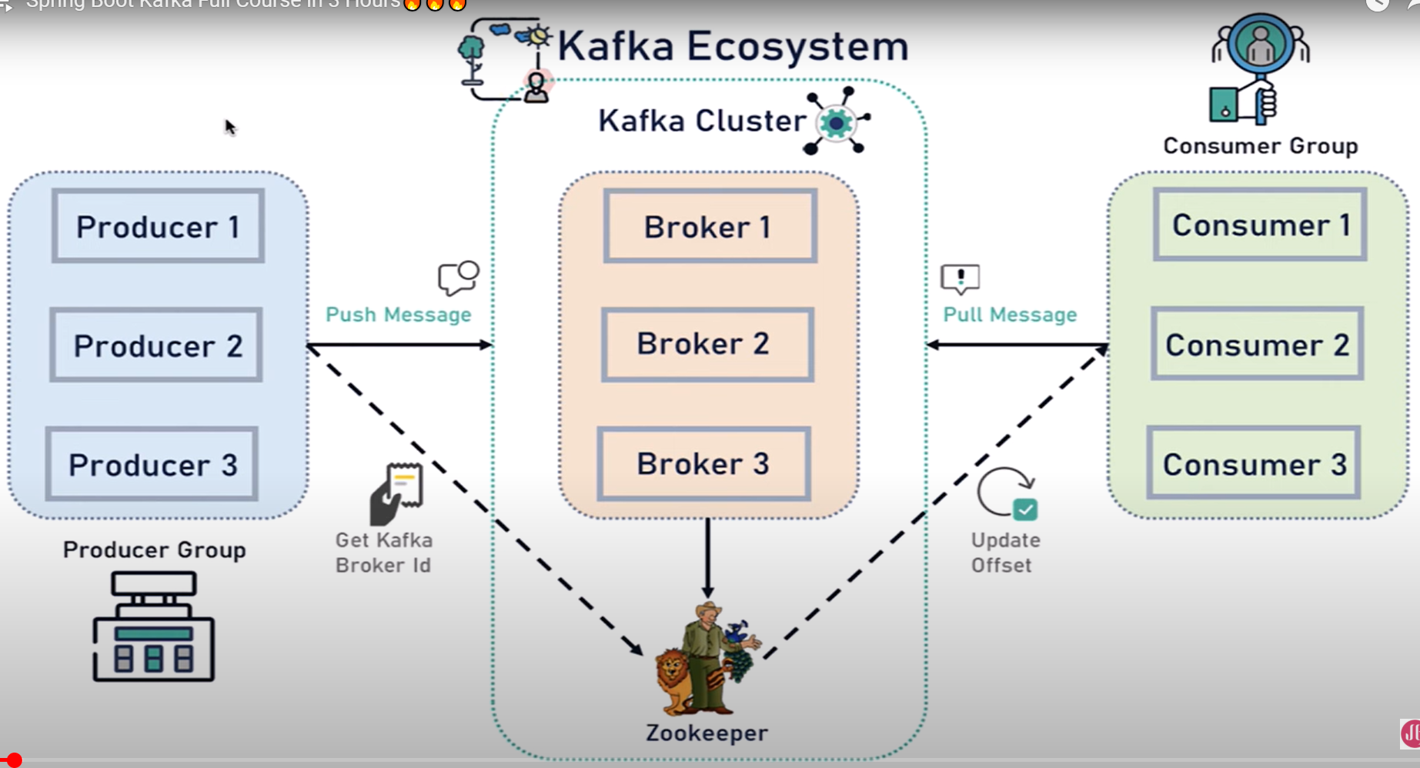

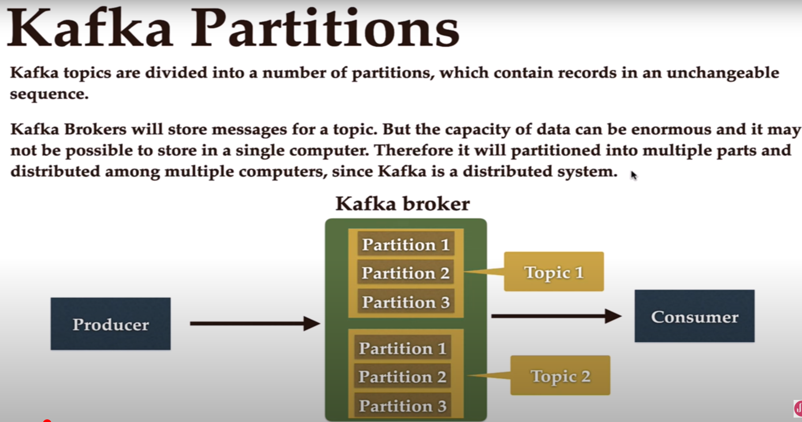

What is a consumer group in Kafka?

* [Apache Kafka](https://codingharbour.com/apache-kafka/)

When sending messages in a distributed setup using a messaging system, you typically have two scenarios you want to achieve. Either you want to:

* send a message to a targeted group of consumers (which might be just one consumer) or
* broadcast the message to all the consumers

Kafka allows you to achieve both of these scenarios by using consumer groups.

Consumer group

A consumer group is a group of consumers (I guess you didn’t see this coming?) that share the same group id. When a topic is consumed by consumers in the same group, every record will be delivered to only one consumer. As the official documentation states: “If all the consumer instances have the same consumer group, then the records will effectively be load-balanced over the consumer instances.”

This way you can ensure parallel processing of records from a topic and be sure that your consumers won’t be stepping on each other toes.

How does Kafka achieve this?

Each topic consists of one or more partitions. When a new consumer is started it will join a consumer group (this happens under the hood) and Kafka will then ensure that each partition is consumed by only one consumer from that group.

So, if you have a topic with two partitions and only one consumer in a group, that consumer would consume records from both partitions.

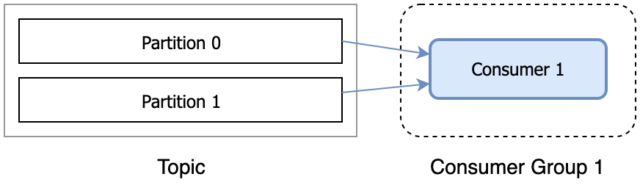A single consumer in a consumer group

After another consumer joins the same group, each consumer would continue consuming only one partition.

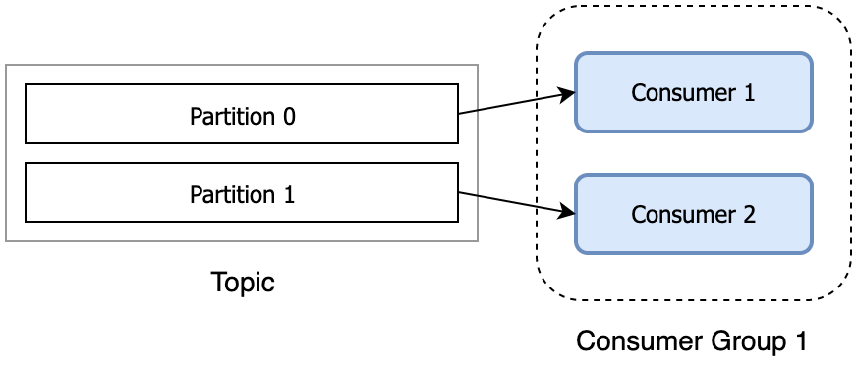Multiple consumers in one consumer group

Does it mean if I want to have more than one consumer (from the same group) reading from one topic I need to have more than one partition?

That is correct. If you have more consumers in a group than you have partitions, extra consumers will sit idle, since all the partitions are taken. If you know that you will need many consumers to parallelize the processing, then plan accordingly with the number of partitions.

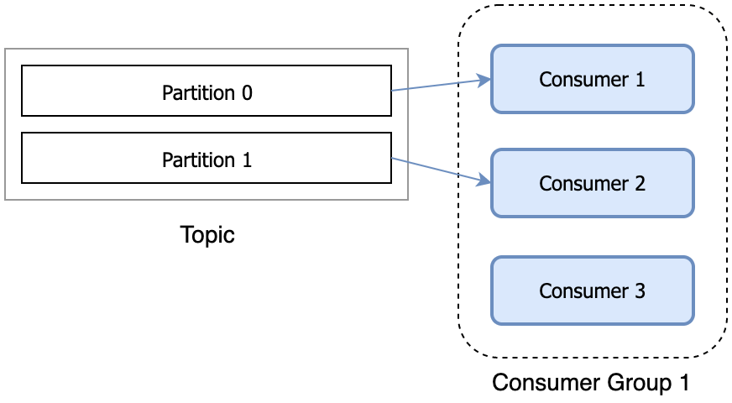Additional consumers in a group sit idly

When we talked about [topics and partitions](https://codingharbour.com/apache-kafka/the-introduction-to-kafka-topics-and-partitions/), I mentioned that a partition is a unit of parallelism from the consumer’s perspective. Now you know the reason – there is a direct link between the number of partitions and number of consumers from a group reading in parallel.

What if I want to consume the same record from multiple consumers?

That is also possible. You can have many consumers reading the same records from the topic, as long as they all have different group ids.

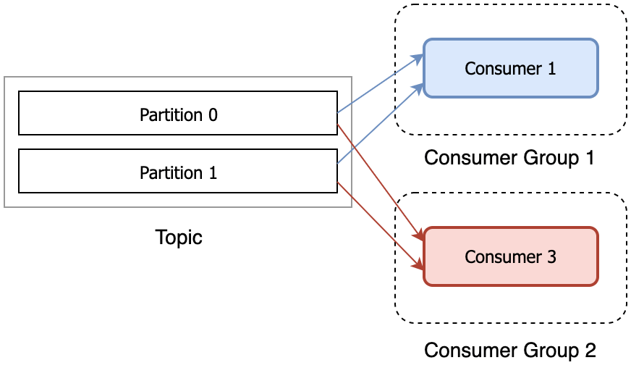Multiple consumers reading the same records from the topic

An example to recap

Let’s illustrate what we’ve been talking about with an example.

Let’s say we’re building an online store and it consists of few microservices that are sending events to each other: payment service, shipping service, and notification service. Once the payment service processes the payment it will send an event PaymentProcessed as a record on Kafka topic. Then we want both the shipping service and notification service to consume this record. The shipping service needs the record in order to start the shipping process, while the notification service wants to receive this record so it could send an email to the customer saying ‘Your payment has been received‘. In this case, we want the PaymentProcessed record to be broadcasted to all the consumers.

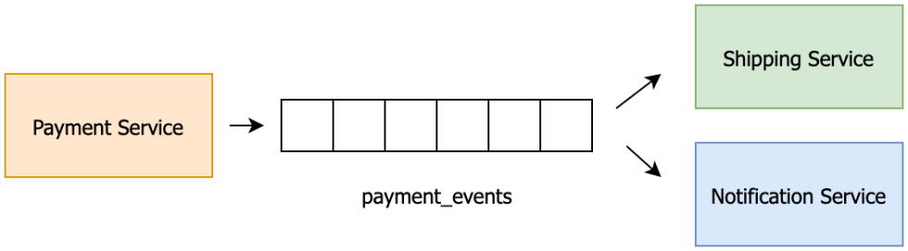Microservices communicating using Kafka

Yet, if we have multiple instances of the consuming services, we always want exactly one of the instances to process each record. For example, we wouldn’t want multiple instances of the notification service to process the PaymentProcessed record and send multiple ‘Your payment has been received’ emails to the customer. Nor would we want multiple instances of shipping service to receive the same PaymentProcessed record and start the shipment process multiple times, potentially losing us money.

To ensure the record reaches both the shipping and the notification service but only once, we would put all the payment service instances in one consumer group and put all the notification service instances in another consumer group.

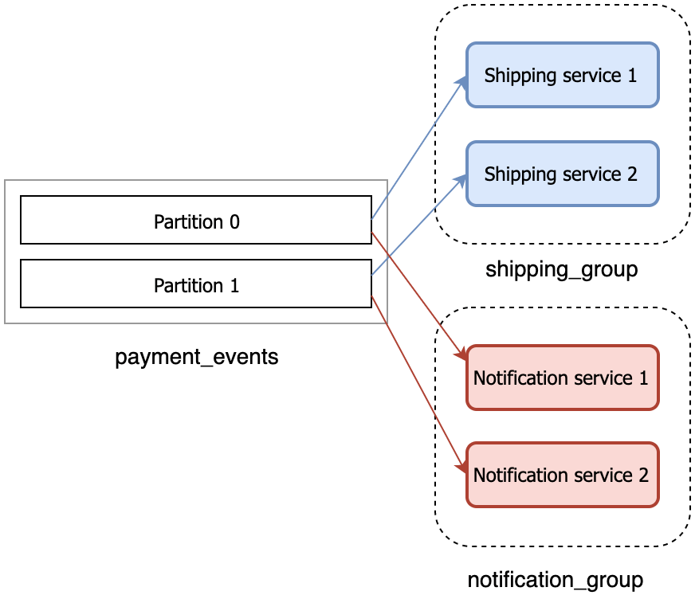Each Kafka record will reach one shipping and one notification service

This ensures that all the records are always read by both shipping_group and notification_group, but within those groups, one record will always go to only one instance. That’s what consumer groups enable us to do.

Code a Producer, Topic and Consumer

Properties:

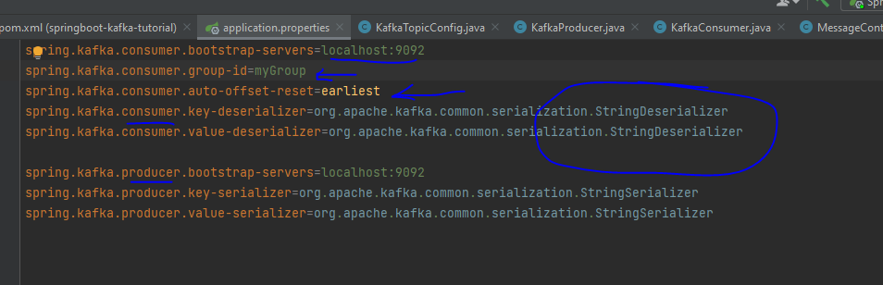

Create Kafka topic:

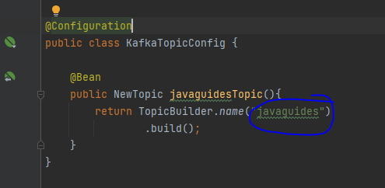

Create Producer to send events by using KafkaTemplate

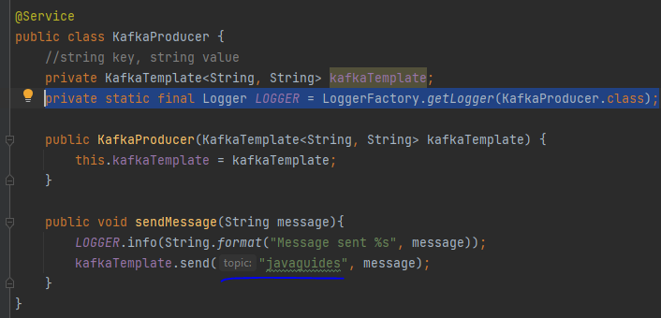

Configure a consumer which listen into the topic for new events

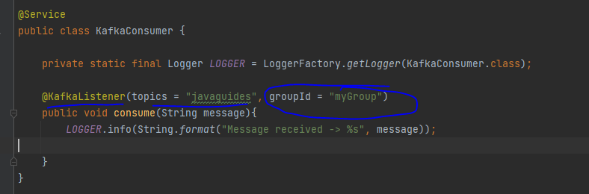

Json Serializer and Deserializer

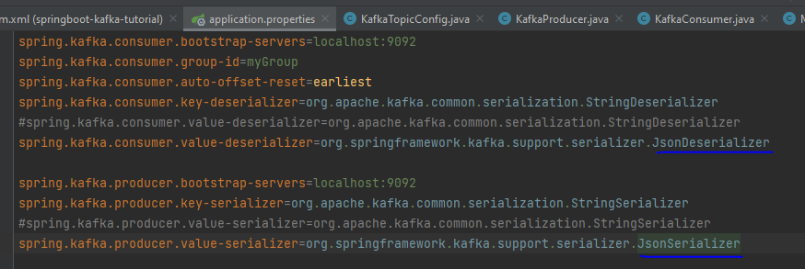

Trust conversion of any type



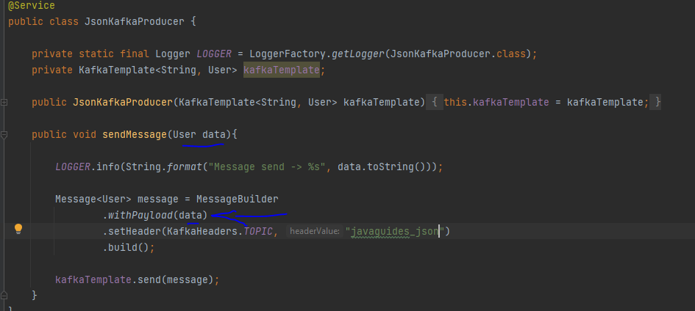

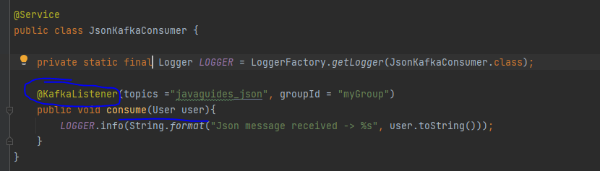

Another consumer ex

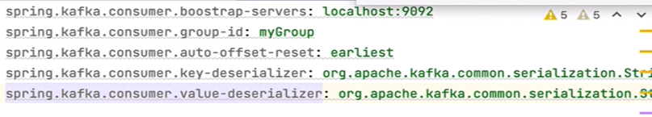

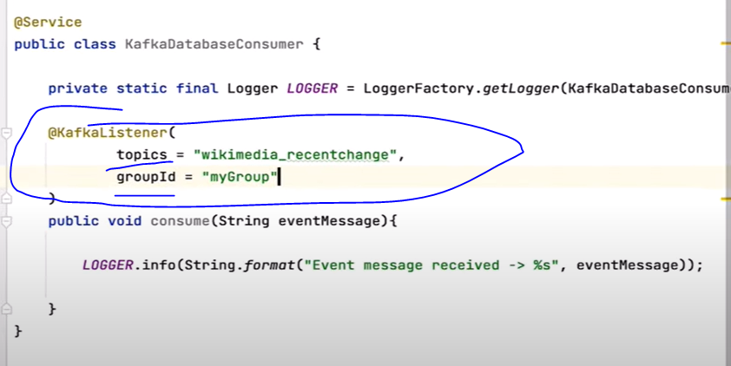

Cache

Most enterprise and web applications use some method of caching. If an application receives a large number of requests, it is often beneficial to store some of the responses in a cache. Then, under certain conditions, the same response can be sent to answer similar requests. Rather than redoing all the processing and computations, returning the previously cached response can save lots of CPU resources.

here are the main classes defined by JSR 107:

CacheProvider,

CacheProvider in Java is an interface or abstract class that provides a mechanism for creating and managing caches. It acts as a factory for Cache instances

Ex: EhCache, Redis, JCS (java caching system)

CacheManager

Manages the lifecycle of caches, including creation, configuration, and destruction.

Provides a way to access and control multiple caches within an application.

Often acquired through a CachingProvider

Cache

A temporary storage area holding frequently accessed data to reduce the need to retrieve it from slower primary storage.

Improves application performance by providing faster data access.

Typically stores data as key-value pairs, similar to a java.util.Map but with added features like eviction policies.

Entry

A Java cache entry represents a single element stored within a cache.

Caching in spring boot

Needs to enable cache by using @EnableCaching annotation in a @Configuration or @SpringBootApplication class

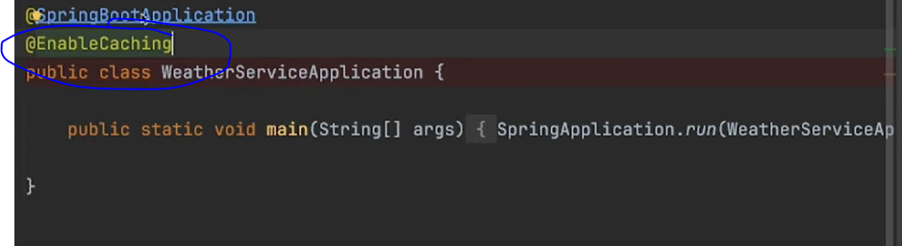

Using @Cacheable, allows to cache the output of our method for same input

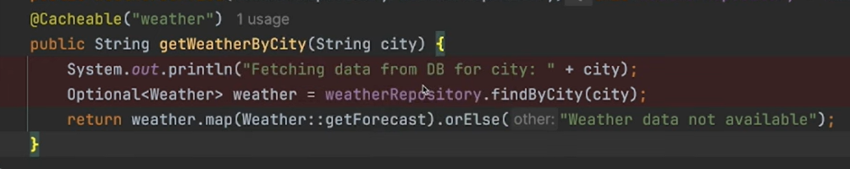

First time it will access the method getWeatherByCity, second time if it has the same city as input, it wont access getWeatherByCity at all, cache will automatically send back the cache result

CacheManager spring class

Allows you to take a look to contents on the cache

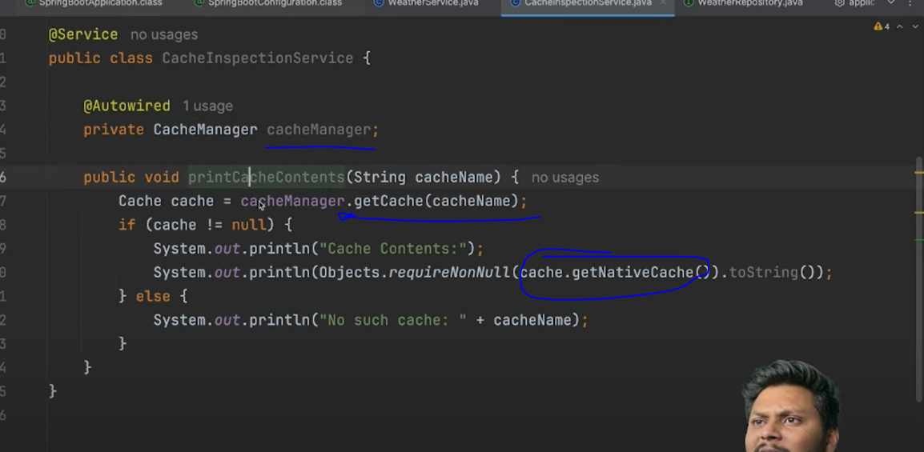

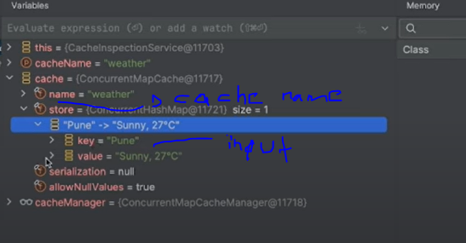

Cache internals concurrent hashmap

Types of caching

In Memory, store in heap memory

In scalation each node will have its own cache, not shared by other nodes which each need to make the same call to cache it losing performance and creating inconsistencies

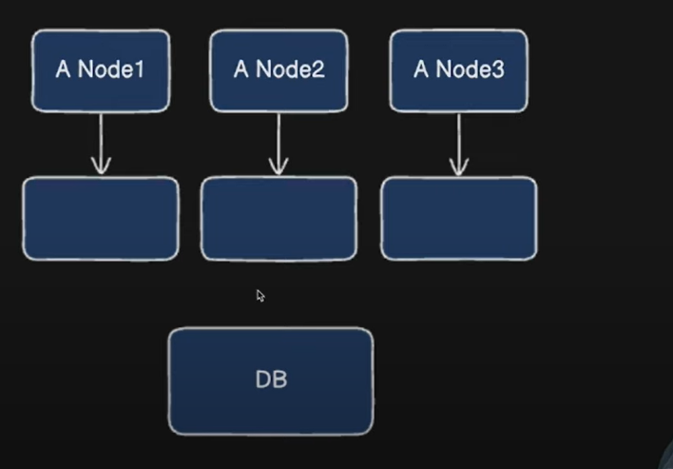

Distributed, example Redis, a single cache outside the application, shared by all nodes

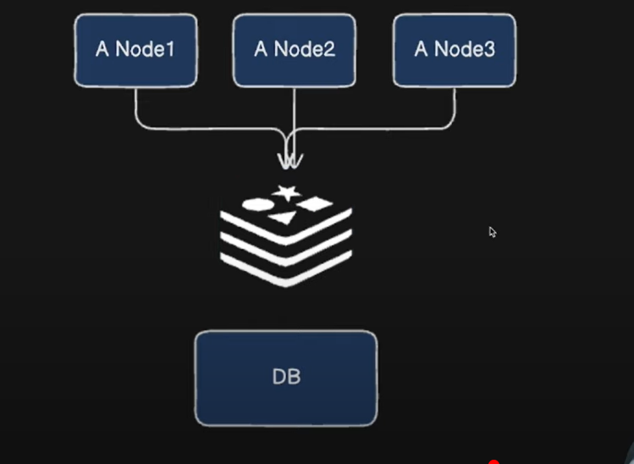

@CachePut

Allows to update cache on updates, ex: you get a weather returned as 22°, then you update weather to 15°, but when you call the get again you still get 22° which is the value existing in the cache, when there is an update to the db, cache should be updated as well @CachePut helps with this. Key makes sure the map stores the correct keys to update instead of adding a new entry in the cache when the CachePut method executes

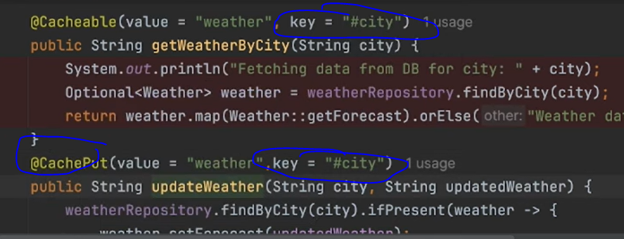

@CacheEvict

Like @CachePut but for deletes to remove from the cache

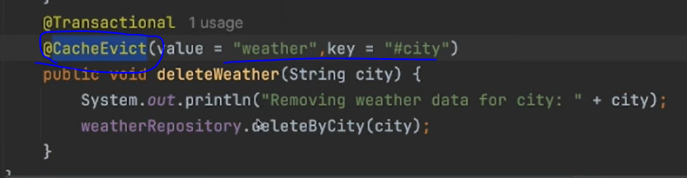

Redis Cache



Redis can store data on ram, making it very fast, can be run in a separate server

Run redis through docker



Configure redis into the spring boot app

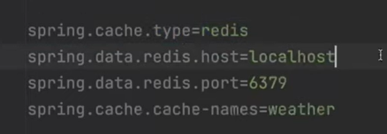

Add dependency

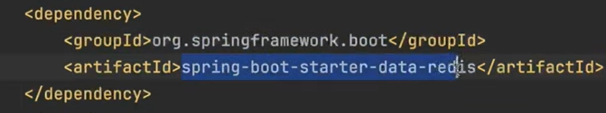

Take a look to redis cache

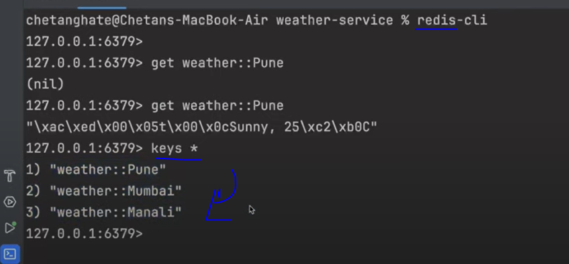

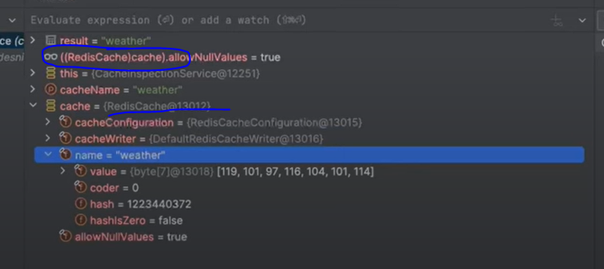

Microservices Scaling

Vertical Scaling:

Increase the resources (CPU, RAM, storage) of the existing server. Suitable for smaller applications but has limitations.

Horizontal Scaling:

Add more instances of the application across multiple servers. Ideal for handling high traffic and is more scalable.

Kubernetes:

A powerful platform for orchestrating containerized applications, offering features like automatic scaling, load balancing, and service discovery.

Kubernetes' Horizontal Pod Autoscaler (HPA) can automatically adjust the number of pods (containers) based on defined metrics like CPU utilization.

Docker Swarm:

A simpler alternative to Kubernetes for container orchestration, especially for smaller deployments.

3. Key Strategies for Horizontal Scaling

Load Balancing:

Distribute traffic across multiple instances of a service. This prevents any single instance from being overwhelmed.

Implementation Approaches

Client-Side Load Balancing:

Uses tools like Spring Cloud LoadBalancer or Ribbon where the client is aware of all available service instances and makes the selection. Spring Cloud LoadBalancer is the modern approach and includes implementations like Round-Robin and Random.

Server-Side Load Balancing:

Involves a dedicated load balancer (e.g., Nginx, HAProxy) that sits between clients and microservices, routing requests.

Service Discovery:

Often paired with service discovery tools like Eureka. These tools allow microservices to register themselves and discover other services dynamically, without hardcoding locations.

Service Discovery:

Use tools like Eureka to enable microservices to find and communicate with each other dynamically, without hardcoded URLs.

Service Registry

A central database or registry that keeps track of information about available services in the system.

Each microservice, when it starts or shuts down, registers or deregisters itself with the service registry.

Service Provider

The microservice that offers a specific functionality or resource is considered a service provider.

Service providers register themselves with the service registry so that other services can discover and connect to them.

Service Consumer

The microservice that needs to use the functionality provided by another service is considered a service consumer.

Service consumers query the service registry to discover the location and details of the service providers they want to interact with.

API Gateway:

Use an API Gateway to manage requests to different microservices, providing a single entry point and enabling load balancing.

Database per Service:

Each microservice should have its own database to prevent resource conflicts.

Asynchronous Communication:

Use message queues (e.g., RabbitMQ, Kafka) for communication between services to decouple them and improve fault tolerance.

Caching:

Implement caching mechanisms (e.g., Redis, Hazelcast) to reduce database load. Use a shared cache for all instances to ensure data consistency.

4. Auto-scaling

Dynamic Scaling:

Automatically adjust the number of service instances based on current demand.

Reactive and Predictive Scaling:

Combine reactive scaling (responding to real-time metrics) with predictive scaling (adjusting based on known traffic patterns).

Spring Cloud

Spring Cloud provides tools for developers to quickly build some of the common patterns in distributed systems (e.g. configuration management, service discovery, circuit breakers, intelligent routing, micro-proxy, control bus, short lived microservices and contract testing).

Features

Spring Cloud focuses on providing good out of box experience for typical use cases and extensibility mechanism to cover others.

Distributed/versioned configuration

Service registration and discovery

Service Registry

Routing

Gateway

Service-to-service calls

Load balancing

Circuit Breakers

Distributed messaging

Spring Cloud bus

It provides a distributed systems communication method that can broadcast events across all connected services as needed.

In a microservice architecture, updating each service individually can be tedious and error-prone. Spring Cloud Bus provides a mechanism to refresh configurations across all services at once.

Spring Cloud Bus offers a way to manage and propagate state changes across all services, reducing the complexity of handling service-to-service communications

Short lived microservices (tasks)

Spring Cloud Task is a framework that facilitates the creation of short-lived microservices

The goal of Spring Cloud Task is to provide the functionality of creating short-lived microservices for Spring Boot application.

In Spring Cloud Task, we’ve got the flexibility of running any task dynamically, allocating resources on demand and retrieving the results after the Task completion.

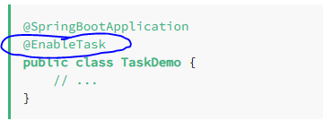

By default, an in-memory map is used to store the status of the TaskRepository.

Ideal for batch processing, ETL (Extract, Transform, Load), data migration, or other tasks that run once and then terminate.